Transformation and Balance in Nature
Nature is always changing. Nature changes each winter, spring, summer and fall. Nature changes each day and night.
Nature is always transforming. A transformation is when one thing is turned into another. Just like we transform food, water, and oxygen into our own bodies, nature is transforming sunlight and soil to plants and plants to animals.
Also, humans transform nature in many big ways. We turn meadows into pasture for cows, and we turn forests into neighborhoods. Everything we own, including our clothes, our computers, our houses and our furniture is a transformation of nature. All these things are made by the human economy. The economy is what transforms nature into things which humans want, like clothes, houses and computers.
In this lesson, we will focus on an important question: Can the human economy continue to transform nature, faster and faster, creating more and more stuff for humans?
Since everything in nature is always transforming, nature works to rebuild itself. How does it do that? Every day, the earth gets free energy from the sun, and plants turn this energy into matter. Sun provides energy so that the plants can continue to grow and the animals and humans can continue to eat plants. This is like our human body; when we eat food each day, the human body rebuilds itself.
But, if humans transform too much of nature into human stuff, nature will not be able to rebuild itself, and instead, nature will begin to fall apart. Therefore, humans should try to find the right amount to transform nature. Since we do not want nature to fall apart, it’s important to create a sustainable economy. In a sustainable economy, humans do not transform nature faster than nature can rebuild itself. Afterall, the human economy won’t work without nature, just like our body cannot work without food.
What would a sustainable economy look like? In a sustainable economy, there would be a balance between the human economy and nature. The economy would not transform nature too fast or too slow. Just like humans eat the same amount each day, the economy would transform nature about the same amount over time.
Consider the human heart, which delivers oxygen to the muscles. It always delivers the right amount. This creates a pattern which we know as our heartbeat. If the heart started to beat too fast, or too slow, it would be very bad for human health. The same is true for economic activity. We want to create a sustainable economy which transforms nature at just the right speed.
Activity: Brainstorm patterns in nature
that would be like a sustainable economy.

Currently, humans are not in balance with nature. The human economy transforms nature too much and too fast. And because of this, the human economy and nature are both out of balance.
The History of Growth and Balance
For the last 12,000 years, nature had great balance. We can tell because the temperature on earth was almost the same every season. Because of this, the plants grew and the animals had food. There was a lot of earth, forests, and water for humans to use and transform for human purposes. Humans began to grow food and then trade food, and because there was extra food and extra time, they began to make tools and other items as well.
As the human economy transforms more and more of nature, we say the human economy is getting bigger and bigger. There are two ways for the human economy to get bigger. One way is for the number of humans to increase. The more humans there are, the more of nature is transformed. Another way is for each human to have more things like clothes, and computers and houses. The more human stuff there is and the more people there are, the more the economy becomes bigger. This is called economic growth. Economic growth means that we are making more human stuff, each year. It also means that more of nature is being transformed to create human stuff.
As the economy has grown, we have developed many things which make the lives of humans better. We have developed great medicine and built safe shelters. We have insured that we can eat food whenever we want. However, now, we get less benefits from having more and more stuff.
Today on earth, every couple of weeks over 10 million new humans are born on earth. This is more than the total number of humans that lived on earth 10,000 years ago, and more than the entire population of Virginia. 10,000 years ago, humans may have shared a tiny hut and had a couple of tools. Today people live in large homes and the average American home has over 3,000 items. The average 10-year-old owns hundreds of toys even if they only use a few. The average American family throws away 65 pounds of clothing per year. The average woman will spend more than eight years of their lives shopping. There are more shopping malls than high schools in the United States and we spend more money on jewelry, watches and shoes than we do on college.
As human populations grow, we use forests, lakes, rivers, and large pieces of the earth for our economic transformations. As we make more human stuff, we are transforming the earth much, much faster than nature can rebuild itself (with help from the sun). Look at the graphs below: In each case there is a line moving upward from left to right. This means that there is more and more and more throughout time; there are more people, there is more resource use, and there are more species going extinct.
Growth in Population, Water Use and Species Extinctions

The first graph shows that there are more people. There are now 7 billion people on earth. For every one person that lived 12,000 years ago, there are 1,400 people today. The next graph shows that we have used more and more water throughout time. On average, a U.S. family uses between 1-2 million gallons of water per year. The third graph shows the number of extinctions occurring. There are more species disappearing because they no longer have homes. In fact, species are losing their homes and going extinct faster than any time since the dinosaurs went extinct 66 million years ago.
Toward a Balanced Economy (A Steady State Economy)
We have become so used to transforming so much, so fast, that we have forgotten how important it is to find balance and allow nature to rebuild itself. For a long time, humans were in an empty world. In an empty world there was so much nature available we thought that our economy could keep getting bigger and bigger. However, now, we are in a full world and we realize that there are limits to growth. Now, there is less and less nature available to transform.
The human economy is kind of like a teenager which has grown as tall as he will. Now that the teenager is so tall, he does not need to keep growing to become any taller. As the human economy finds balance with nature’s economy it will go from being a growing economy to its maximum height and then it will be a balanced economy. A balanced economy is called a steady state economy. Currently, we transform nature, more and more, faster and faster and the economy grows bigger and bigger. In the future, the economy will no longer be a growing economy. It will not continue to transform nature more and more, faster and faster. It will be a balanced, steady state economy. In a steady state economy, the number of people will be the same over time, and the amount of economic stuff that each person consumes will be the same over time.

Conclusion
Over time, humans have become excellent at transforming nature into stuff like refrigerators, houses, computers and food. For a long time, nearly 12,000 years, the human economy has been growing bigger and bigger and bigger. Because it has been growing so much, so fast, there is less and less of nature, and further, nature is falling apart. The temperatures go up and down more and there are more storms.
In the future, humans are aiming to have a balanced economy. A balanced economy will not be growing or shrinking. It will not transform the earth faster than the earth can rebuild itself. Because of this, the transformations will be steady, and this type of economy is called a steady state economy. In future lesson plans we will discuss more about the steady state economy and we will also talk about more ways that human economies and nature interact.
Activities and Discussion
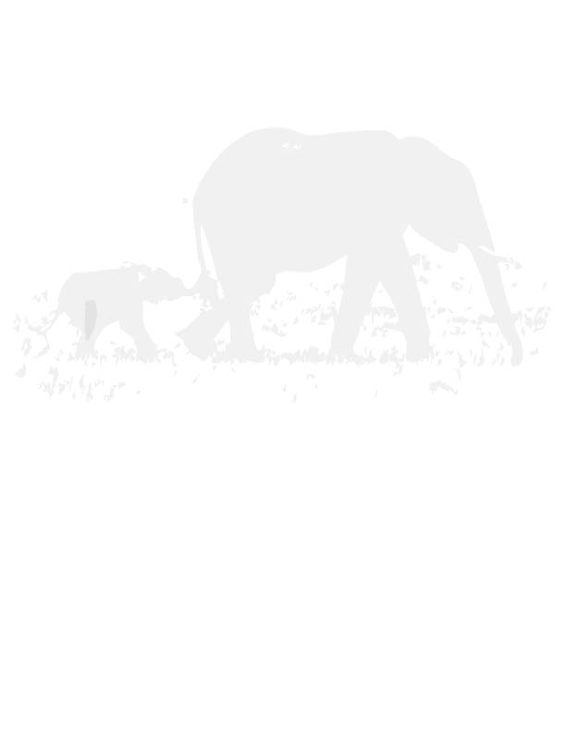
Exploring the nature of growth vs. balance
Using Legos or blocks. Start building a town or city. Slowly add new pieces. First, add the pieces one at a time, then two at a time, then three at a time. These blocks are like resources from nature. When there are no blocks left the town or city cannot keep growing and growing. This is like the human economy. However, just because it cannot keep growing, does not mean that it cannot keep improving. Working together, rearrange the blocks to improve the buildings. This is like a steady state economy because life is getting better, but we are no longer taking more and more resources from nature and the economy is no longer growing and expanding.
Some additional elements to consider: As we re-arrange, are there some blocks that we don’t use? Where do these blocks go? Back into the environment as waste?
Also, does it take energy to build the city and re-arrange it? Where is this energy coming from? In the classroom, it is coming from the food that the students eat. In the economy, it is coming, mostly from fossil fuels, which are limited.
Now begin with some land designated as farm or forest, perhaps marked by green and brown blocks. As the economy develops, we must use this land to build buildings and roads. What happens if the population is increasing? We need more houses and more farms, and therefore less forest. Slowly, there are less resources and less land. Agriculture will need to take up about half the space in order to feed all of the people, and forests will need about 20% of the space in order to maintain biodiversity and climate stability.
Metaphors
Discuss metaphors and their importance in art and science. What are some metaphors for the relationship between humans and nature? (Bring up ancient metaphors: e.g. ‘mother nature’ and current ones. e.g. ‘empty world vs. full world.’)
Balance and Transformation:
Draw an ecosystem. Together as a class discuss each ecosystem, and think of all the ways that it changes, and all the ways it stays balanced over time. E.g. seasonal changes, long term changes, human caused changes., regeneration, solar energy.
a. Transformation. What are some non-human transformations in your ecosystem? What turns into what? What is some human caused transformation in your ecosystem?
b. Balance. What is an example of balance in your ecosystem? Does the sun help to maintain this balance?
c. Do you think that the human economy is too big, too small or the right size relative to your type of ecosystem?

