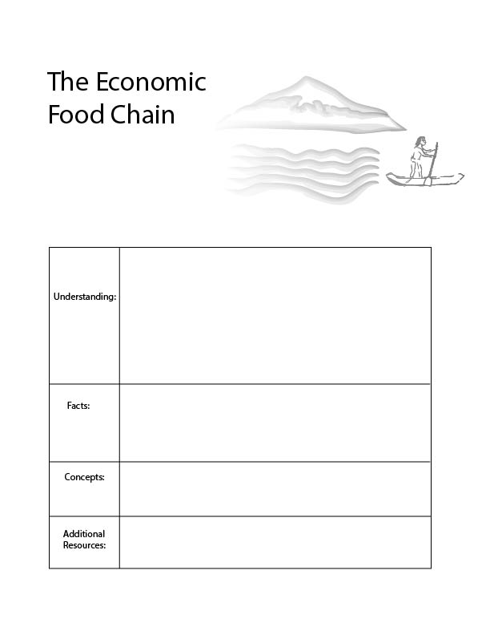

- Food chain/ trophic structure
- Expansion of the economic network and structure
In the economy of nature, there exists many levels and we call these levels the trophic structure. The trophic structure is similar to the food chain. Plants and are the primary producers in the trophic structure because they use solar energy and produce food. Some animals eat plants and some animals eat animals that eat plants.
A similar structure exists in the economy. At the base of the economy we draw on ecological resources such as oil, timber, water and metal. There are then various stages of manufacturing which add value. There is a strong relationship between what is happening at the bottom of the economy and the top of the economy.
Food webs:
https://www.youtube.com/watch?v=Cd1M9xD482s
There are three basic layers in nature’s food chain: Plants, animals that eat plants and animals that eat animals.
There are three basic layers in the economy’s food chain: Resource extractors, heavy manufacturers, and light manufacturers.
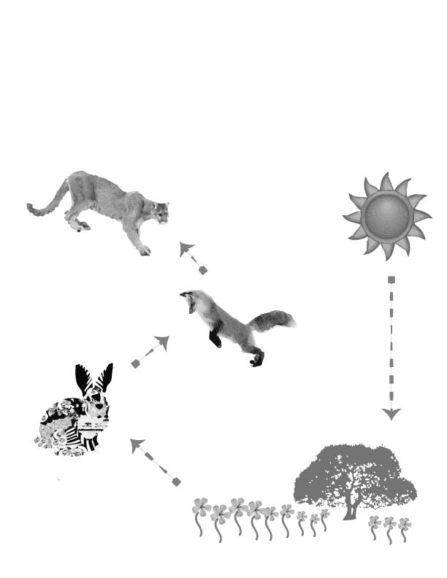
Lesson 3. The Economic Food Chain
All of nature is linked together in what we generally refer to as the food chain and what scientists call the trophic structure. In nature, there are plants, some animals eat plants, some animals eat animals. All of nature starts with the energy from the sun.
Look at this illustration and follow it step by step, starting with the sun.
- The first producers such as trees, grass, and flowers get energy from the sun and with this energy they produce food for animals and insects.
5. The top carnivores eat animals that eat animals. They’re called the third consumers.
4. Some animals eat these animals, like foxes. They eat animals that eat plants and they are called the secondary consumers.
3. Some animals only eat plants. They’re called the first consumers, or herbivores.
- The sun shines down on plants providing energy.
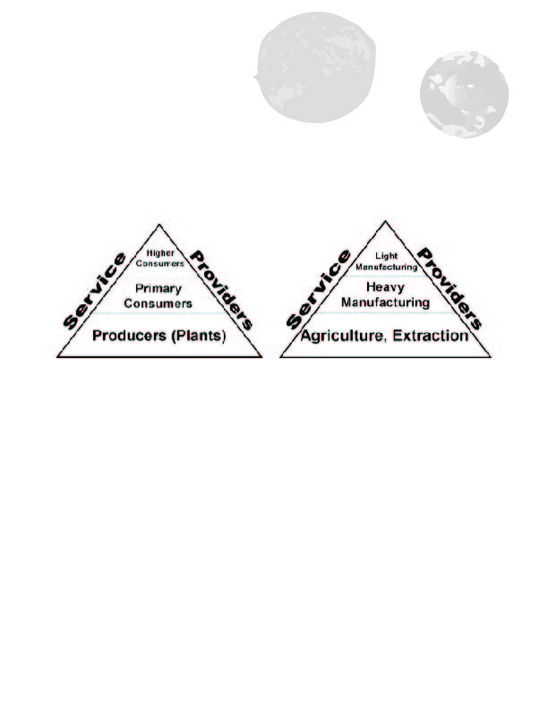

Nature’s food chain begins with plants. Plants can turn energy from the sun into food, so plants are the first step in nature’s food chain. An example is an oak tree that produces acorns. One step higher, in nature’s food chain, there are species that eat plants. This includes insects, animals, and even humans. An example is a squirrel that eats acorns. These species are the second step in nature’s food chain. They do not create food, like plants; rather, they eat plants. One step higher in nature’s food chain, there are those that eat the animals that eat plants. For instance, a fox that eats a squirrel. These are the three main steps in nature’s food chain: plants, animals that eat plants, and animals that eat animals.

The human economy also has a similar food chain. In the first step in the economic food chain, we gather materials from the earth, such as water, trees, oil, metal and crops like cotton or carrots. At the second step in the economic food chain are manufacturers which transform these materials. For instance, some businesses turn trees into wood, clay into bricks, and earth elements into steel. They take the materials from the earth and transform them.
The third step in the economy’s food chain is what we call light manufacturing. Light manufacturing includes the creation of things like computer chips requiring much more detailed work. These manufacturers combine materials from earlier stages to make something that costs more money.
When we consider the trophic structure of the ecosystem, we realize that the health of the higher consumers and primary consumers, depends on the health of the primary producers - the plants. When we think about the economy in this way, we also realize that manufacturing sectors and service providers also depend on the base of the economy: the materials that come from nature.
In the next sections, we will use examples of computers and pizza. These two examples are actually quite similar. Imagine the first time that pizza was produced. People probably thought that this was a wonderful technology. Combining these ingredients and then cooking them together with fire. Today, we produce technologies that also seem wonderful and new. As the economy grows it combines materials in new ways to produce new products. However, these technologies always depend on raw materials.
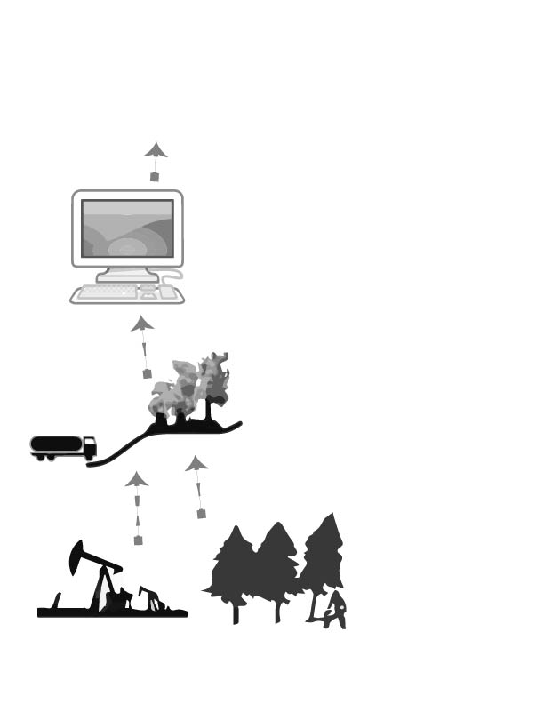
Read this section and imagine different products which we consume like clothes, books, and cell phones. Which raw materials were necessary to produce these products? What kind of jobs are there at each step of production?
1. All things we produce in the economy depend on raw materials from nature such as oil, timber, and water. The first producers in the economy extract these raw materials from the earth.
3. At the next level, companies use these materials to make new products, such as computers.
2. These raw materials are then transported to a factory which turns the materials into something useful for the economy. This is generally considered heavy manufacturing. These are the first consumers.
4. Throughout the economy, information helps people to organize economic activity and design economic products. This is like having a coach on a soccer team. As economies grow, and become more complicated, there is a greater demand for this.
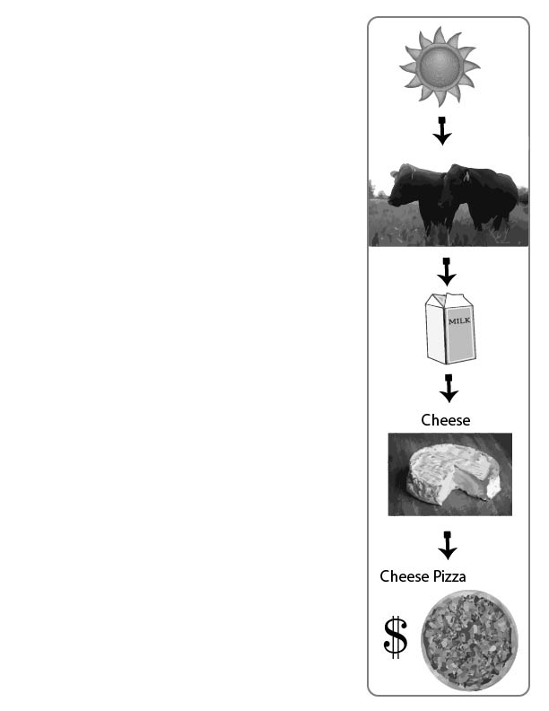
Grass, milk, cheese and pizza.
Let’s consider a farm with cows. The grass in the field grows with help from the sun and earth. This grass provides food for the cows. Then, the cows produce milk. Each of these steps adds more value in the human economy. We cannot sell sunlight. We cannot make very much money selling grass. But we can make more money selling milk!
There are a lot of business decisions a farmer can make. Maybe the farmer can sell the milk. Or, maybe she can use milk to produce cheese. If the farmer has more time, she may even want to use the cheese to produce pizza. Maybe the farmer can buy wheat and tomatoes from her neighbor, in order to create pizza. She can use the sun to grow grass, the grass to feed cows, the cows to produce milk, the milk to produce cheese, and the cheese to produce cheese pizza. At each step she gets more money from her grass, wheat and tomatoes.
If the farmer is a good business woman, she will make much more money at each stage. She will make more money from pizza than cheese, and more from cheese than milk, and more from milk than grass.
However, the farmer cannot forget that the success of her business ultimately depends on the grass, which is the food for the cows which make the milk which produces the cheese which is put on the pizza. Knowing this, a smart farmer and good business person will make sure that the grass grows long, and that the cows are well fed.
When we think about our economy in general, it is just like a pizza. It depends on many ingredients from the earth.
Today, around the world, we are quickly running out of these essential economic ingredients that are used to make all our economic products.
Some of the essential ingredients include land, water, energy, forest, metal and nutrients for our food.
Unfortunately, we have over 7 billion people on the planet, and some of these people want to buy a lot of stuff. Therefore, we are using all of the ingredients much faster than they can be regenerated. It is as if we are making so many pizzas that we are running out of cheese and milk and then we are adding more cows. But since there are more cows on the land, the cows are hungry and there is little grass left.
Just as the pizza-making farmer maintains lots of healthy grass, smart economists make sure that we are letting earth’s ecosystems regenerate.

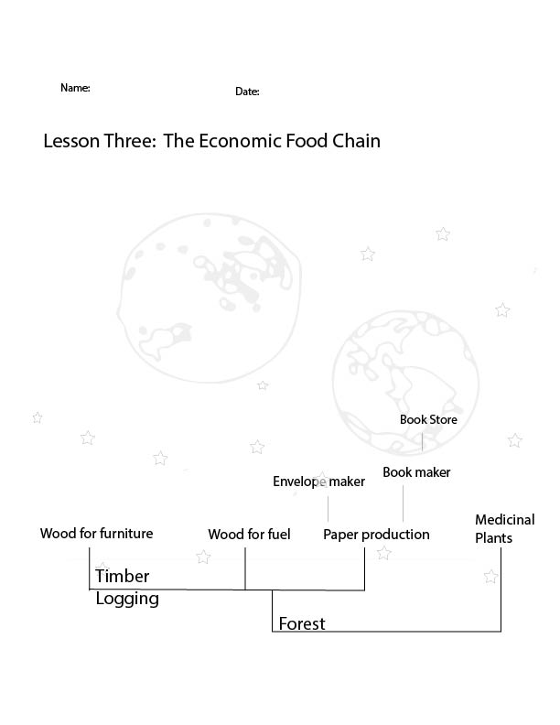
Name a species on the first level of the trophic structure in nature.

Pick a species that is on the second level of the trophic structure in nature.

Pick a species that is on the third level of nature’s trophic structure.

What types of economic activities are on the first level of the economic food chain?

Below is a chart that includes many products that come from a forest. What would happen if we sold too many books? What are some ideas for making more money in this particular part of the economy?

