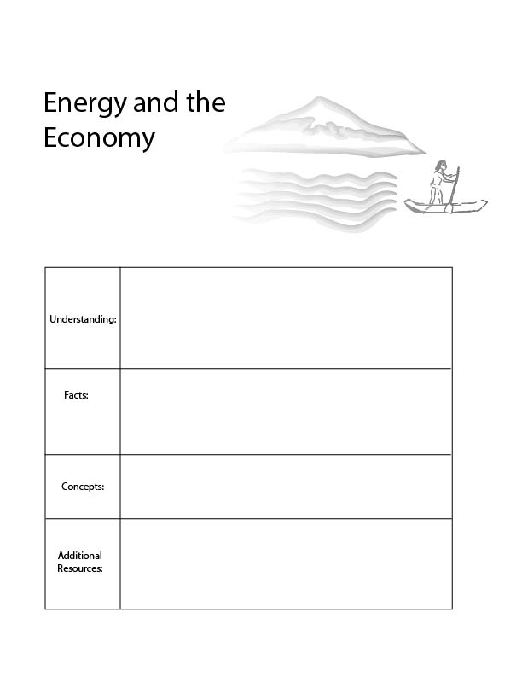
Agro-ecology for kids:
https://www.youtube.com/watch?v=bLqYE-m2nE4
- Economic efficiency
- Energy efficiency
- All economic activities require energy.
- It requires 55 calories to kick a soccer ball even though our body only uses 1 calorie to do so.
For every economic product we create, we spend a certain amount of energy creating it. An inefficient economy is one in which we waste a lot of energy to create our economic products.
Economies become more efficient when we work with nature, rather than against it, such as in the case of agro-ecology.
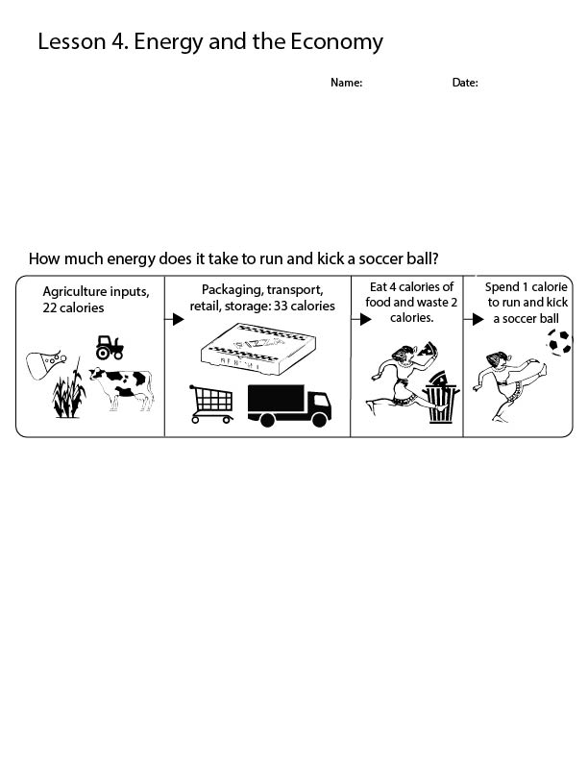

One of the key ingredients in the economy is energy. In past lessons, we talked about making sure that the economy is the right size so that it is in balance with nature and nature’s capacity to regenerate. In this lesson, we’ll focus on the relationship between economic activity and energy production.
We want to create the best economy with the resources available to us. This means that we want an economy to be sustainable, but also efficient. Efficiency suggests that we want to create the most economic value with the materials that we use from earth. Currently the economy is very efficient with the use of money but very inefficient with the use of energy.

A calorie is an amount of energy, just like a pound is an amount of weight. On average, we use 55 calories to kick a soccer ball, even though our body only uses 1 calorie of energy to kick a soccer ball.
This is because we use a lot of energy at each step in the food supply chain. We produce chemicals to put on our crops, we drive our tractors, and we feed our livestock. All of this takes extra energy. Then we package our food, ship it far around the world, and hold it in refrigerators before we cook it! In the United States, we then waste 4 out of 10 calories by throwing food in the garbage. We waste 140 trillion calories per year! When we finally eat the food, our body is able to use about 1/4 of the energy that it consumes.
However, energy does not regenerate nearly this fast. We can grow some plants to use for energy, but we also need these plants for other purposes. Most of the energy we use is from oil, and oil is going to run out eventually.
What would an efficient economy look like? In an efficient economy, we would make the most out of the energy available to us! Let’s think about what an efficient economy would look like in the case of our food system.
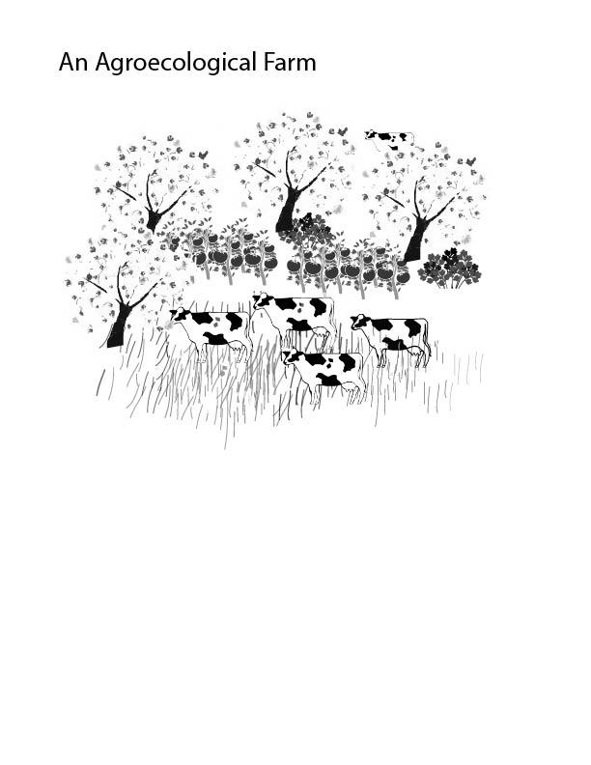

Creating an efficient food economy would mean that we would have to work with nature. There is a special science called agroecology that focuses on producing food that works with nature. Imagine a farm, in which we did not have to use energy to pump water, or chemicals to manage pests. Imagine that the ground absorbed rain water and birds ate many of the unwanted pests. We would use way less energy, and water, and we would hurt the wildlife less. Imagine if we did not ship this food from around the world, and instead we simply got it from down the road. This would also use less energy. Imagine, if instead of putting the food into boxes and adding food coloring, we carried the food in a bag and ate it, as it was. If we did all these things, we would be much more sustainable and energy efficient. It turns out that we would also be healthier. This way, all the wildlife on our farm can take advantage of the sunlight, and if we are very careful, it is possible that we can even increase the amount of energy we have. Even though the plants and animals use energy, they also absorb it from the sun.
When we work with nature, we place all different crops together and form a small plant and animal community. This way the water can get captured by the plants and the plants and animals create each other’s food, and some of the pesky insects just become food for the birds! In this way, we need a lot less energy to produce all of the food because nature’s natural food web helps us on the way.
It may not be realistic to change our entire food system over night, but we can learn a lesson from farms like this. When we work with nature, we use far less energy.

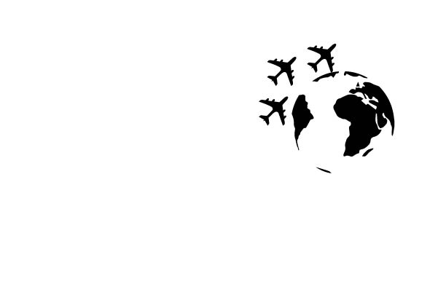
There are also many things that we could do to reduce our packaging, transport, retail and storage emissions.
On average, our food comes from 1,500 miles away. This transport requires a lot of energy. In order to reduce this energy use, we can grow our food closer to home.
During some periods in history we have grown a lot of food in our gardens. This is the most efficient way to grow food, and would help us a lot in creating a sustainable and efficient economy.
Energy and the Economy Questions

Say you want to kick a soccer ball; what will help you become more efficient in doing so?

What are some ways in which the economy can become more efficient?

Keyword: Ecosystem Service
An ecosystem service is a benefit provided by nature to the economy. For instance, when it rains, crops are watered, and plants grow. When the sun shines, plants absorb solar energy, and farmers profit from this. Often times, we don’t realize that a service is being provided by the ecosystem until it’s no longer there, such as in the case of a drought or a particularly cloudy year. In these conditions, crops don’t grow, and farmers may struggle to make a profit.

