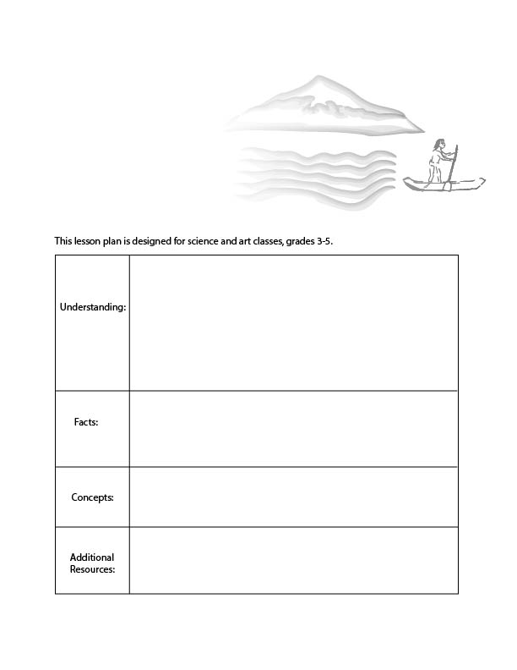
Economic Cycles and Nature
Ecological inputs
Waste absorption capacity
Sustainability
There is a cycle of economic activity. This cycle is produced by exchanges between businesses and households.
Nature gives inputs (resources) for economic exchange and also receives outputs from economic exchange (waste).
Therefore, economic exchanges are constrained by nature’s resources and capacity to absorb waste.

In the economy there is exchange in the following forms: money, goods and services, labor, and income. This is supported by ecological inputs and waste absorption capacity of the ecosystem. The
economy cannot grow forever.

Videos about pollution: https://www.youtube.com/watch?v=OqHp03RRTDs
Video about ecosystem services:
https://www.youtube.com/watch?v=r7UCAsBT5Yg

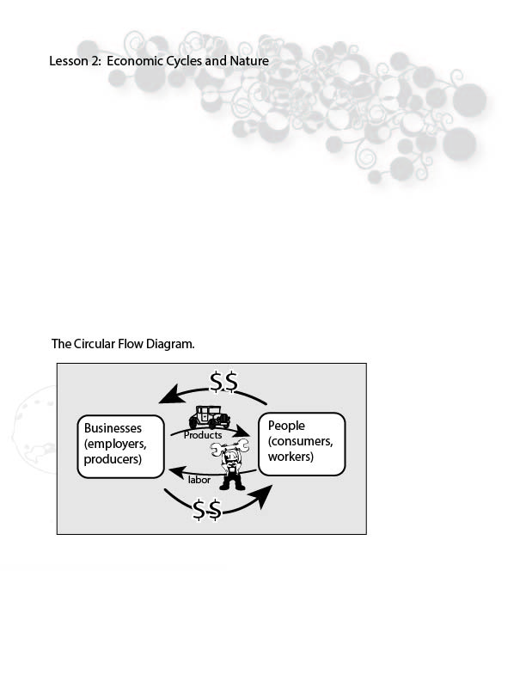

People who study the economy focuses on businesses, consumers, and workers.
Businesses make products such as clothing, food, houses and much more.
Consumers buy all of these products from businesses. They buy cars, clothes, houses, food and much more.
Workers are people that work at businesses to create all the products that people buy like cars and clothing. Economists call workers “labor”.
Also, workers get paid money. If workers were not making money, many of them probably wouldn’t want to work.
In the economy there are businesses that make economic products and pay workers, and there are people that buy stuff (consumers) and people that work for businesses (labor). These are the main actors of the human economy. We can think about them all together with this image.

This diagram is called the circular flow diagram because money flows around in a circle between people and businesses. Money goes back and forth as people buy stuff and are paid for their work. Is there anything missing from this picture?

For a long time, economists have only studied the circular flow of money, and because of this, they believed that the economy could grow forever. However, we know that If the human economy grows too much then it will impact our ecosystems, and our economy depends on our ecosystems.
When the economy grows, there is less and less earth which is available for other species, and also less earth which is available to be used for economic activities.

Nature does a lot of work for the economy. The sun provides energy for plants. The plants provide food for animals. The plants and animals help forests grow and help to grow our food. Nature creates all the raw materials that we use for the economy!
In order to better understand this, it will be useful to distinguish sources and sinks.
A source is the part of the environment that provides raw materials, such as a forest which is a source of timber.
Aquifers are a ‘source’ of fresh water, which exist beneath the ground. Humans depend on water from aquifers but aquifers recharge water at a very slow rate. We are rapidly depleting our supply of fresh water which is contained within aquifers, and they will not be re-filling any time soon.
A sink is the part of the environment that receives the economy’s waste flow. For instance, the forests and oceans absorb many pollutants which are a result of economic activity.
The oceans are a CO2 ‘sink’. As we emit more and more CO2, the oceans have been able to absorb a certain amount of it. However, at this point the ocean cannot absorb any more CO2.
As they relate to the economy, we can call sources and sinks ‘ecosystem services’.
An ecosystem service is a benefit provided by nature to the economy. For instance, when nature provides water, and crops grow, this water creates economic value for farmers who then sell these crops. The ecosystem regenerates itself in order to provide raw materials, cycle water and nutrients, and maintain stable weather patterns.
Our new model of the economy does not just include consumers, workers, businesses and money. It also includes the earth, which provides sources of raw material and energy, as well as ecosystem services like waste absorption.

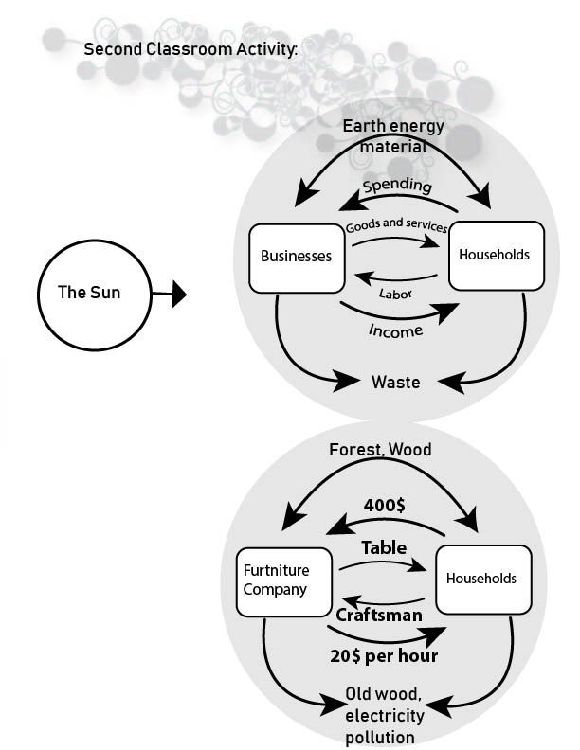
Pick an economic product. Map this onto the following model. How does this economic good or service use energy and material? How does the product produce waste? How much does the product cost?

What labor is needed to produce the product and how much income does this labor require?
Example.
1. Table. Tables come from wood and forests. Labor produces a table with some machinery. A table might cost 400$. A laborer might spend 10 hours and make 20$ per hour. When the table is no longer used it is thrown into the junk yard.

