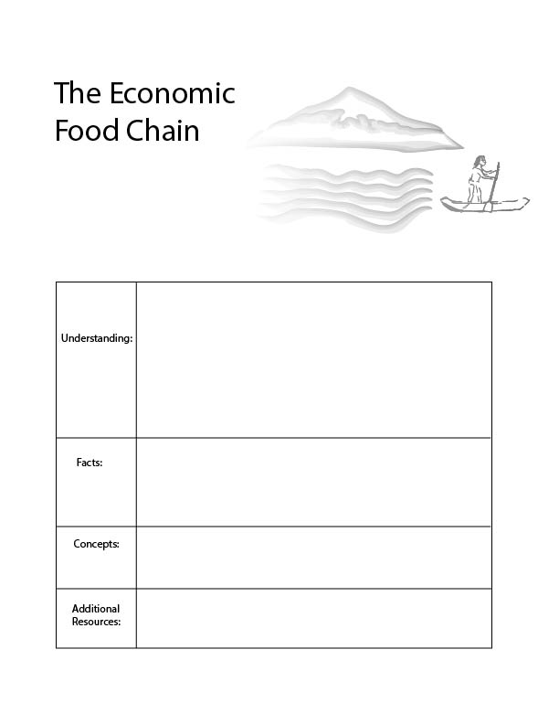

Food webs:
https://www.youtube.com/watch?v=Cd1M9xD482s
- Food chain/ trophic structure
-Expansion of the economic network and structure
There are three basic layers in nature’s food chain: Plants, animals that eat plants and animals that eat animals.
There are three basic layers in the economy’s food chain: Resource extractors, heavy manufacturing, and light manufacturing.
In the economy of nature, there exists what we call a trophic structure. We understand this like a food chain. Plants and are the primary producers in the trophic structure because they use solar energy and produce food. Some animals eat plants and some animals eat animals that eat plants.
A similar structure exists in the economy. At the base of the economy we draw on ecological resources such as oil, timber, water and metal. There are then various stages of manufacturing which add value. There is a strong relationship between what is happening at the bottom of the economy and the top of the economy.
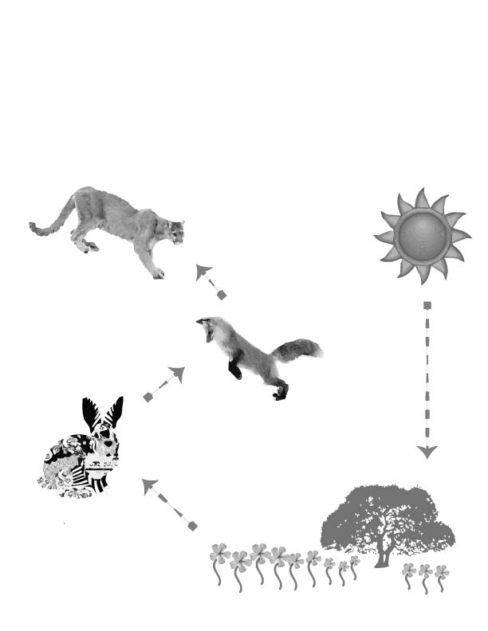
Lesson 3. The Economic Food Chain
All of nature is linked together in what we generally refer to as the food chain and what scientists call the trophic structure. In nature, some animals eat plants, some animals eat animals that eat plants, and some animals eat animals that eat animals. All of nature starts with the energy from the sun.
Look at this illustration and follow it step by step, starting with the sun.
- The first producers like trees, grass and flowers get energy from the sun and with this energy they produce food for animals and insects.
5. The top carnivores eat animals that eat animals. They’re called the third consumers.
4. Some animals eat these animals, like foxes. They eat animals that eat plants and they are called the secondary consumers.
3. Some animals only eat plants. They’re called the primary consumers, or herbivores.
- The sun shines down on plants providing energy.
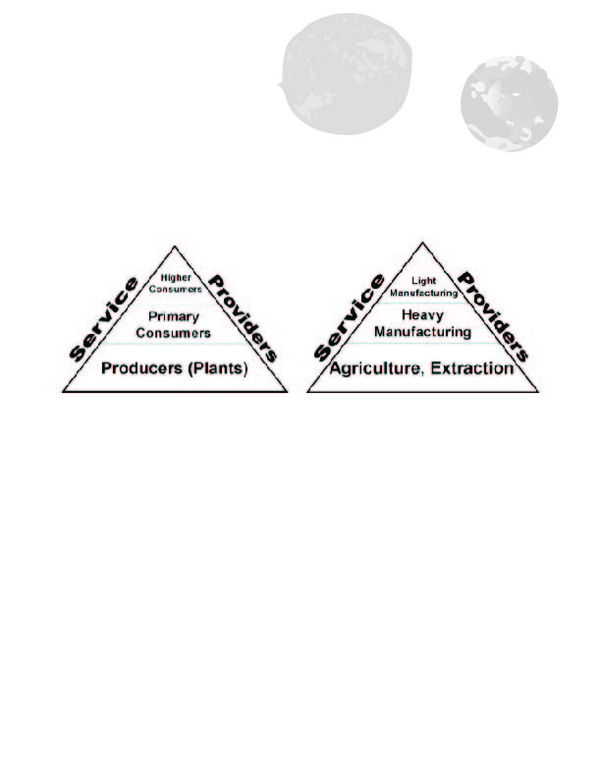

Nature’s food chain begins with plants. Plants can turn energy from the sun into food and so plants are the first step in nature’s food chain. An example is an oak tree that produces acorns. One step higher, in nature’s food chain, there are species that eat plants. This includes insects, and animals, and even humans. An example is a squirrel that eats acorns. These species are the second step in nature’s food chain. They do not create food, like plants; rather, they eat plants. One step higher, in nature’s food chain, there are those that eat the animals that eat plants. For instance, a fox that eats a squirrel. These are the three main steps in nature’s food chain: plants, animals that eat plants, and animals that eat animals.

The human economy also has a similar food chain. In the first step in the economic food chain, we gather materials from the earth, such as water, trees, oil, metal and crops like cotton or carrots. At the second step in the economic food chain are manufacturers which transform these materials. For instance, some businesses turn trees into wood, clay into bricks, and earth elements into steel. They take the materials from the earth and transform them.
The third step in the economy’s food chain is what we call light manufacturing. Light manufacturing includes the creation of things like computer chips requiring much more detailed work. These manufacturers combine materials from earlier stages to make something that costs more money.
When we consider the trophic structure of the ecosystem, we realize that the health of the higher consumers and primary consumers, depends on the health of the primary producers - the plants. When we think about the economy in this way, we also realize that manufacturing sectors and service providers also depend on the base of the economy: the materials that come from nature.
In the next section, we will use the example of computers, and then an example using pizza. These two examples are quite similar. Imagine the first time that pizza was produced. People probably thought that this was a wonderful technology. They were probably awe struck by the idea of combining these ingredients and then cooking them together with fire. Today, we produce technologies that also seem wonderful and new. As the economy grows it combines materials in new ways to produce new products. However, these technologies always depend on raw materials.
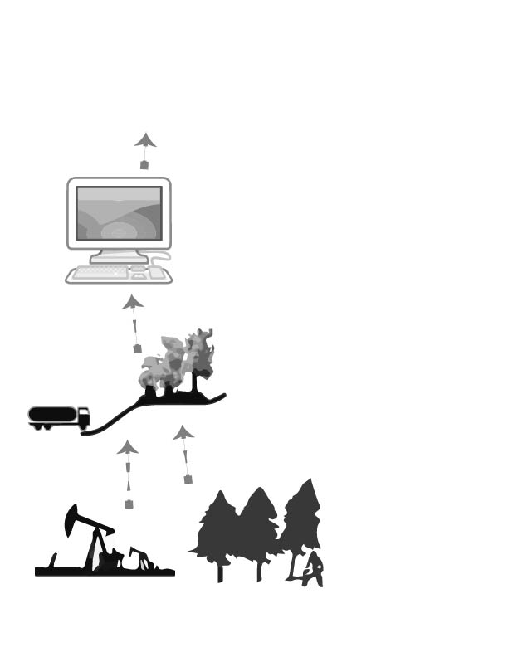
Read this section and imagine different products which we consume like clothes, books, or cell phones. Learn about what happens to create this product at each step. Which raw materials were necessary to produce this product? What kind of jobs are there at each step of production?
1. All things we produce in the economy depend on raw materials from nature such as oil, timber and water. The first producers in the economy extract these raw materials from the earth.
3. At the next level, companies use these materials to make new products, such as computers.
2. These raw materials are then transported to a factory which turns the materials into something useful for the economy. This is generally considered heavy manufacturing. These are the first consumers.
4. Throughout the economy, information helps people to organize economic activity and design economic products. This is like having a coach on a soccer team. As economies grow, and become more complicated, there is a greater demand for this.
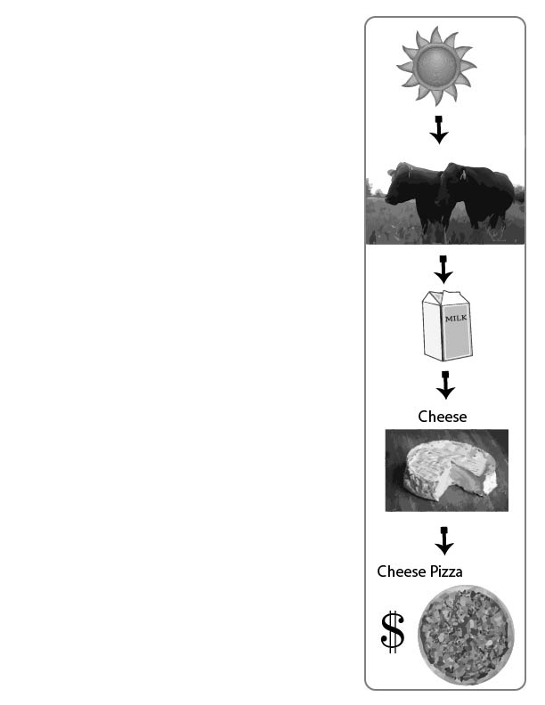
Grass, milk, cheese and pizza.
Let’s consider a farm with cows. The grass in the field grows with help from the sun and earth. This grass provides food for the cows. Then, the cows produce milk. Each of these steps adds more value in the human economy. We cannot sell sunlight. We cannot make very much money selling grass. But we can make more money selling milk!
There are a lot of business decisions a farmer can make. Maybe the farmer can sell the milk. Or, maybe she can use milk to produce cheese. If the farmer has more time, she may even want to use the cheese to produce pizza. Maybe the farmer can buy wheat and tomatoes from her neighbor, in order to create pizza. She can use the sun to grow grass, the grass to feed cows, the cows to produce milk, the milk to produce cheese, and the cheese to produce cheese pizza. At each step she gets more money from her cows and grass.
If the farmer is a good business woman, she will make much more money at each stage. She will make more money from pizza than cheese, and more from cheese than milk, and more from milk than grass.
However, the farmer cannot forget that the success of her business ultimately depends on the grass, which is the food for the cows. Knowing this, a smart farmer and good business person will make sure that the grass grows long, and that the cows are well fed.
When we think about our economy in general, it is just like a pizza. It depends on many ingredients from the earth.
Today, around the world, we are quickly running out of these essential economic ingredients that are used to make all our economic products.
Some of the essential ingredients include land, water, energy, forest, metal and nutrients for our food.
Unfortunately, we have over 7 billion people on the planet, and some of these people want to buy a lot of stuff. Therefore, we are using all of the ingredients much faster than they can be regenerated. It is as if we are making so many pizzas that we are running out of cheese and milk and then we are adding more cows. But since there are more cows on the land, the cows are hungry and there is little grass left.
Just as the pizza-making farmer maintains lots of healthy grass, smart economists make sure that we are letting the earth regenerate in materials.

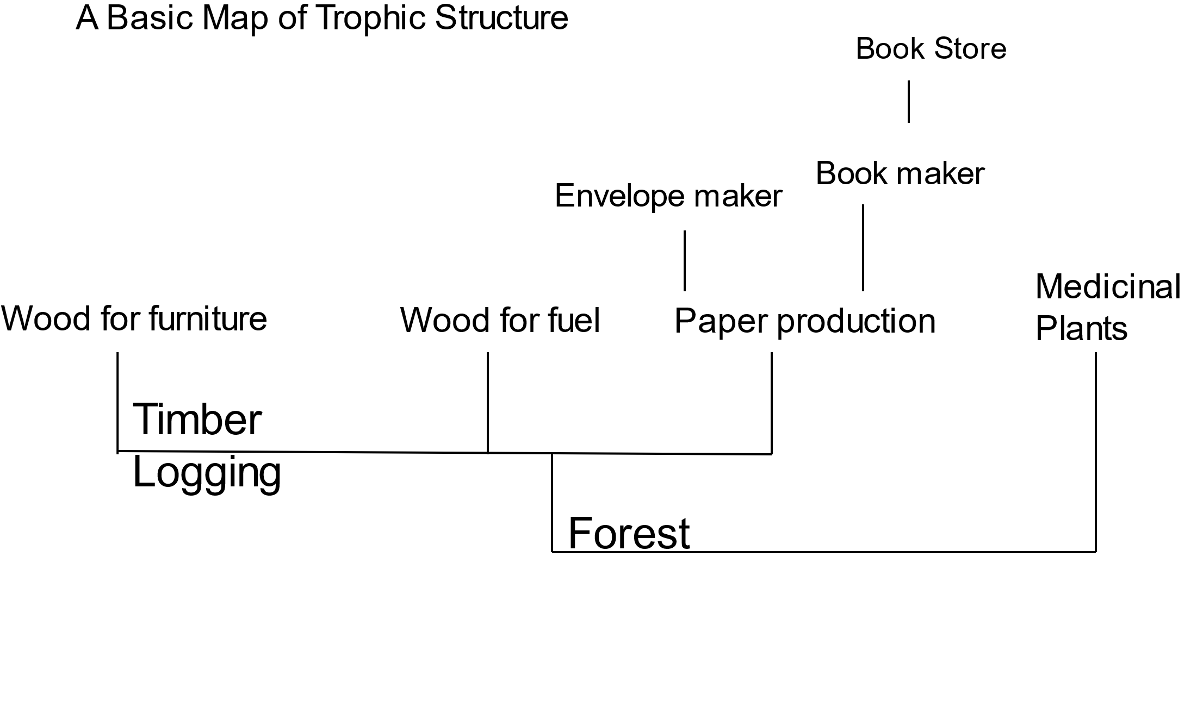
When we think about the entire economy, we can picture it like the branches of a tree. In the first stage of the human economy, suppliers extract raw materials and energy from nature. At this level we have farmers, miners, loggers, oil riggers, frackers, and water utilities for example. Let’s imagine the case of using the forest to create products. Timber may go to a paper mill, and then to a book maker and finally to a book store. The above representation is simple because in each case lower levels of production may depend on sophisticated instruments which have been produced using a large combination of elements. For instance, the equipment used to cut down trees is itself a product that has advanced through many stages in the trophic order.
Paper historians in the UK have estimated that there are 20,000 uses for paper. 20,000? If we were to include all these purposes for paper our graph would be extremely wide. As economies grow, these trophic structures expand in both width and height. How can a graph expand in height? Consider the many steps along a supply chain that are involved before we walk into a book store. Supply chains grow in height when raw materials need to be further and further refined, and combined before they become a final product.
As the trophic structure expands, an economy must become more efficient, or it appears, they create more ‘economic value’ with less raw materials. Think about the value that happens when we combine, paper, ink, and a narrative. We get a book! A book, worth much more than the ink, paper and narrative alone. Book stores have even combined books with cafes. This combining, in some cases leads to greater value, and in other cases leads to less value. If it leads to greater value than it becomes another link in the supply chain. It becomes a new economic product that is sold.
So, it takes more energy to make a book than to make only paper, ink and narrative. However, we get much more value from the book than all those elements themselves.

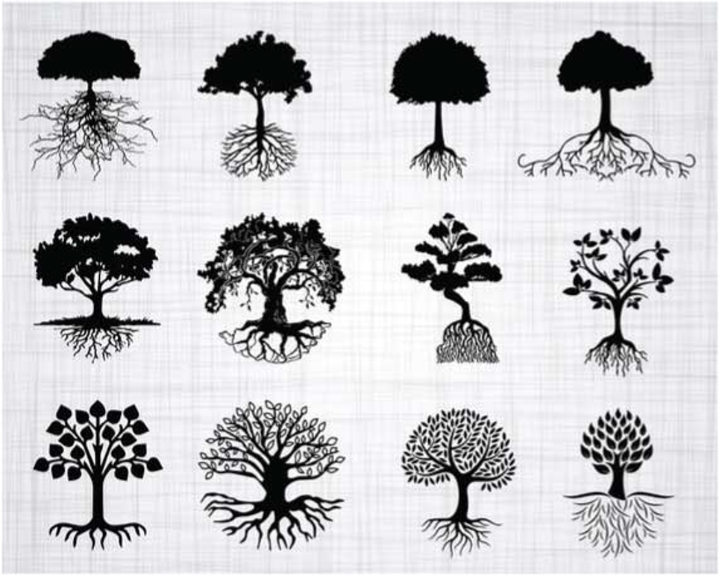
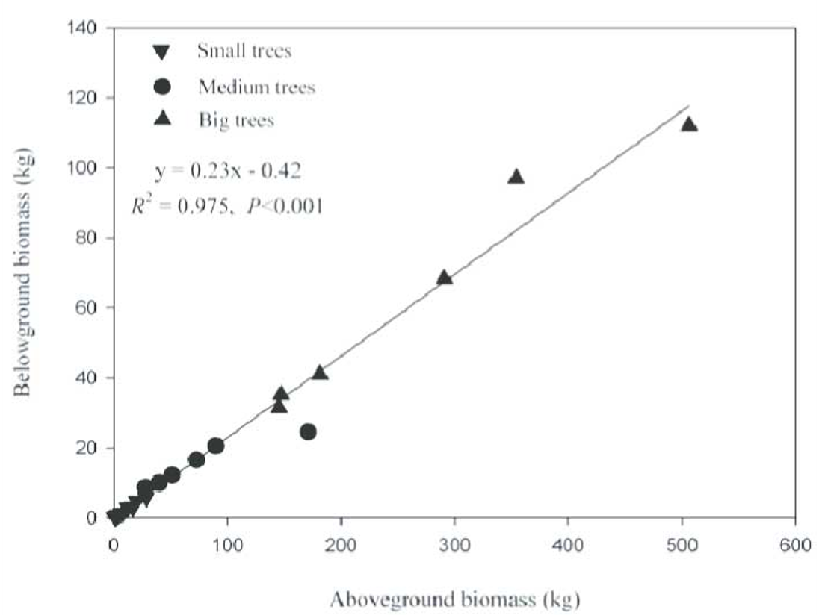
When trees grow, do they only grow, do they only grow up in height? When we look at a tree, we see that the roots grow as the branches grow. Or, more accurately, the part of the tree that is below ground (below ground biomass) grows in proportion to the part of the tree that is above ground (above ground biomass). The top of the tree does not expand, without the expansion of the roots.
This is also true of the economy. The more that the economy grows vertically, the more the economy must also expand at the base.
The graph to the right demonstrates this relationship with trees. For five units of above ground biomass growth, there is one unit of below ground biomass growth.
When we think about the trophic structure of the economy the same thing is true. As the economy creates more types of products, which are worth more money, the extractive sectors (the roots of the economy) also grow proportionally, albeit more slowly.

This also gives us an understanding for the role of technology in an economy. Some people think that technology can help us to use less resources while continuing to grow the economy, but this is because they do not understand the role of technology within the context of this economic network. In future lesson plans, we will work learn more about the relationship between the expansion of economic networks and energy and material use. For now, let’s consider the metaphor of ‘tree growth’.

The Economy Grows as an Integrated Whole
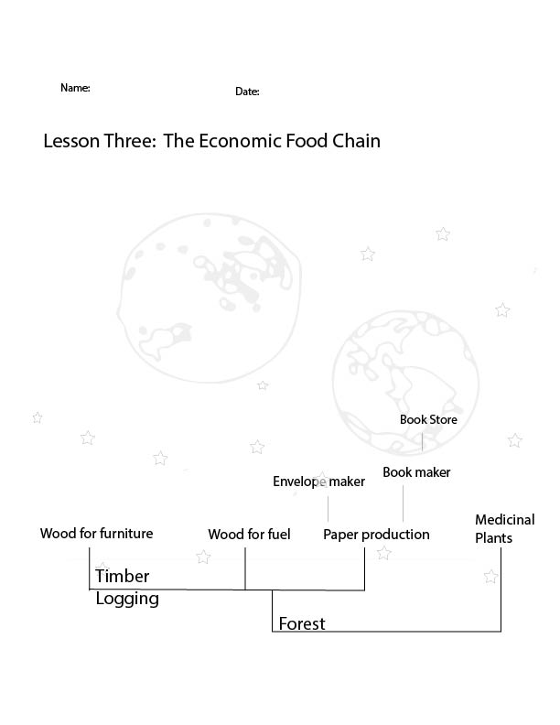
Who are on the first level of the food chain in nature?

Pick a species that is on the second level of nature’s food chain.

Pick a species that is on the third level of nature’s food chain.

What types of economic activities are on the first level of the economic food chain?

Below is a chart that includes many products that come from a forest. What would happen if we sold too many books? What are some ideas for making more money in this particular part of the economy?

