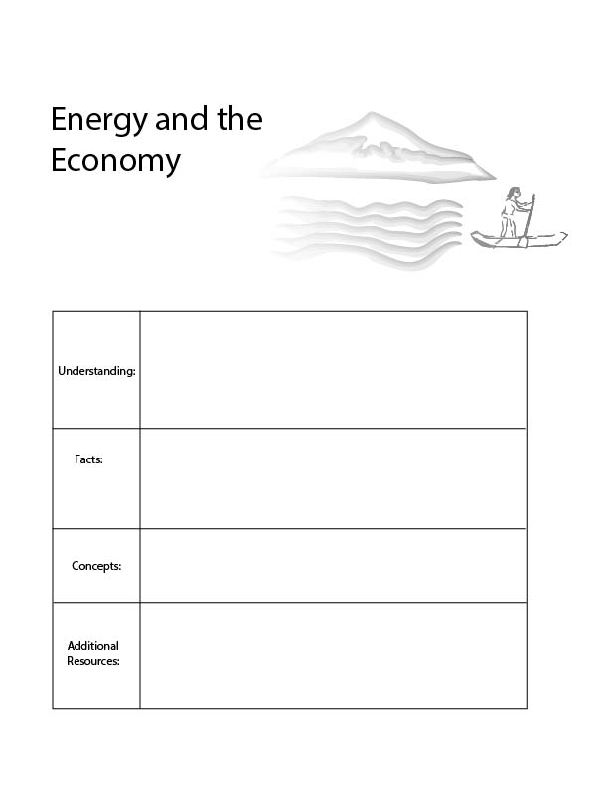
Agro-ecology for kids:
https://www.youtube.com/watch?v=bLqYE-m2nE4
- Economic efficiency
- Energy efficiency
- All economic activities require energy.
- It requires 55 calories to kick a soccer ball even though our body only uses 1 calorie to do so.
For every economic product we create, we spend a certain amount of energy creating it. An inefficient economy is one in which we waste a lot of energy to create our economic products.
Economies become more efficient when we work with nature, rather than against it, such as in the case of agro-ecology.

Energy and the Economy

In the previous lesson we focused on the trophic structure of the economy. We learned that the economy can grow in both width and height, and as it does, it increases its total impact on the ecosystem, but also becomes more efficient.
In this lesson, we will focus more narrowly on the relationship between energy and the economy. As an economy develops and GDP per person increases, so does the total amount of energy that the economy uses. However, at the same time, the economy uses that energy more efficiently. As GDP per person, doubles, energy use per person increases 1.5 times. This pattern is consistent across economies and throughout the past half a century. Remarkably the same rule is true for biological organisms. As an organism doubles in weight, it requires only 1.5 times as much energy. For instance, humans weigh approximately twice as much as many small deer species, and we consume 1.5 times as much energy.
However, even though we become more efficient as we grow, we must be careful because our energy supply is limited. The earth receives a certain amount of energy from the sun each year, and a certain amount of this energy has been captured in useable forms like fossil fuels.
Let’s consider the relationship between energy consumption and food production in order to examine the effect of economic development on energy consumption.

A calorie is an amount of energy, just like a pound is an amount of weight. On average, we use 55 calories to kick a soccer ball, even though our body only uses 1 calorie of energy to kick a soccer ball.
This is because we use a lot of energy at each step in the food supply chain. We produce chemicals to put on our crops, we drive our tractors, and we feed our livestock. All of this takes extra energy. Then we package our food, ship it far around the world, and hold it in refrigerators before we cook it! In the United States, we then waste 4 out of 10 calories by throwing food in the garbage. We waste 140 trillion calories per year! When we finally eat the food, our body is able to use about 1/4 of the energy that it consumes.
Activity: Map elements of the food system like the ‘tree map’ from the last lesson plan. How has the food economy grown in width and height?
Now, let’s consider a new approach to growing food.

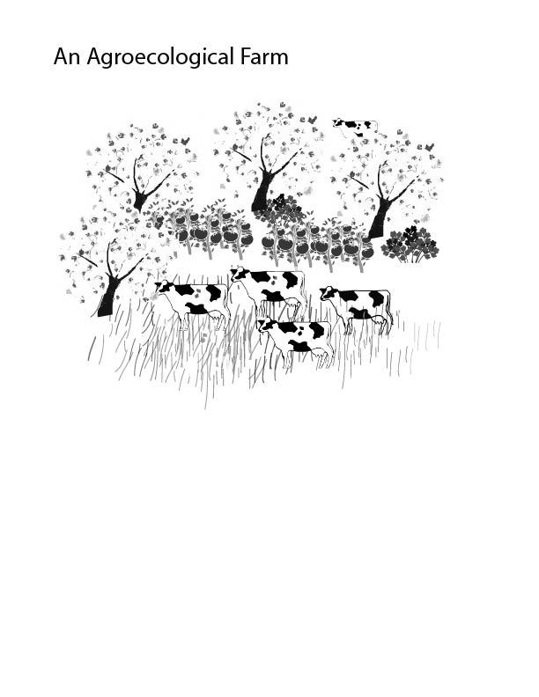

Creating an efficient food economy would mean that we would have to work with nature. There is a special science called agroecology that focuses on producing food that works with nature. Imagine a farm, in which we did not have to use energy to pump water, or chemicals to manage pests. Imagine that the ground absorbed rain water and birds ate many of the unwanted pests. We would use way less energy, and water, and we would hurt the wildlife less. Imagine if we did not ship this food from around the world, and instead we simply got it from down the road. This would also use less energy. Imagine, if instead of putting the food into boxes and adding food coloring, we carried the food in a bag and ate it, as it was. If we did all these things, we would be much more sustainable and energy efficient. We would also be healthier. However, we would also see less economic growth. Think about all the businesses which currently help provide food. There are companies that modify seeds, companies that help farms gain access to water, companies that develop chemicals, companies that transport food and supermarkets that hold our food items for us. If we created a more efficient food system, it might be better for humans and nature, it might provide jobs to many more farmers, but it would not create economic growth.
When we work with nature, we may achieve our goals, and we may use energy much more efficiently, but GDP may decline. When we work with nature, we place all different crops together and form a small plant and animal community. This way the water can get captured by the plants and the plants and animals create each other’s food, and some of the pesky insects just become food for the birds! In this way, we need a lot less energy to produce all of the food because nature’s natural food web helps us on the way.
It may not be realistic to change our entire food system over night, but we can learn a lesson from farms like this. When we work with nature, we use far less energy.

Conclusion:
There are also many things that we could do to reduce our packaging, transport, retail and storage emissions.
On average, our food comes from 1,500 miles away. This transport requires a lot of energy. In order to reduce this energy use, we can grow our food closer to home.
During some periods in history we have grown a lot of food in our gardens. This is the most efficient way to grow food, and would help us a lot in creating a sustainable and efficient economy.
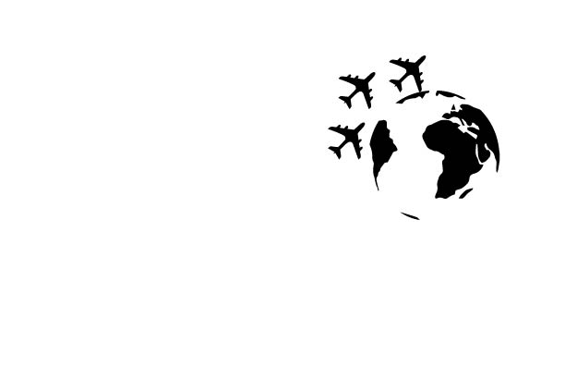
Creating an efficient economy may be better for people, and it may be much better for nature, but it may not increase the total amount of economic activity. In a future lesson plan we will talk about creating an economy which is the optimal size for human well-being.
Energy and the Economy Questions

Say you want to kick a soccer ball. What will help you become more efficient in doing so?

What are some ways in which the economy can become more efficient?

