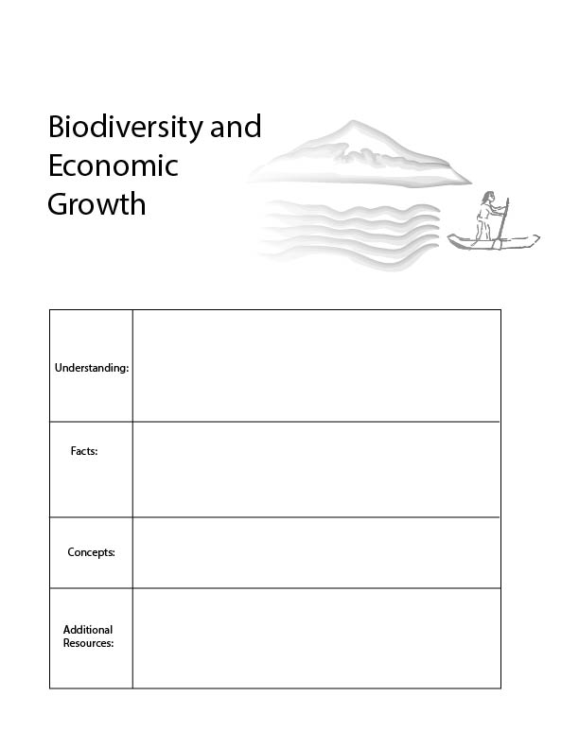
In a short time period, we have seen a very large number of species go extinct, never to return. This is not good for ecosystems because ecosystems depend on biodiversity. This is also not good for our economy because our economy depends on our ecosystem.
Food growing:
https://www.youtube.com/watch?v=bLqYE-m2nE4
- Species extinction
- Habitat
- Economic causes of biodiversity loss
- The current rate of biodiversity extinction is unprecedented since the time of the dinosaurs.
- Forests are very valuable for biodiversity.
- Building cities and growing food are many drivers of biodiversity loss.

Species are going extinct (dying off forever) faster than any time in the last 66 million years, since the time of the dinosaurs. Scientists estimate that since, 1970, less than half of the wildlife population remains.
In our lesson plans so far, we have begun to discuss tradeoffs between current economic activity and future prosperity. One important tradeoff to consider is the protection of other species including both wildlife populations and biodiversity.
Biodiversity simply refers to diversity among plants and animals. The more kinds of plants and animals there are, the more biodiversity. Our ecosystem is like a gigantic puzzle of pieces that all fit together. Each plant and animal depends on other plants and animals in their environment, for food, for shelter, and community. Therefore, biodiversity is so important. If all the pieces of the puzzle were the same, they could never fit together, and we would not have ecosystems. Because plants and animals work together, they can create life, and maintain their homes.

A few extinctions
25 million years ago, there lived a species called the Paracetherium. This rhinoceros like species is the largest known mammal to walk the earth, with a shoulder height of over twenty feet.
Living until about 5 million years ago, there lived a bird called the Argentavis, whose wingspan could be nearly twenty feet.
10,000 years ago, we began to witness a great contemporary extinction, as humans moved into the Americas. The ground sloth was perhaps the easiest target, a slow-moving herbivore, resembling modern sloths, this species weighed up to 9,000 pounds and stretched over 20 feet in length.
Imagine a beaver that is over 6 feet long. Giant beavers died out roughly 12,000 years ago.
Glyptodons were a species that lived up until about 10,000 years ago. They resemble modern day armadillos, except that they were about the size of a car.
Now, you may have heard about the 1100-pound animal called the saber tooth tiger. This cat species survived for roughly 42 million years, but was no match for humans and died out about 11,000 years ago. And about that time, we lost wholly mammoths as well.
What about the last 400 years? 400 years ago, we saw the extinction of the Dodo bird, (a fan favorite) and just in 2011, the white rhino.
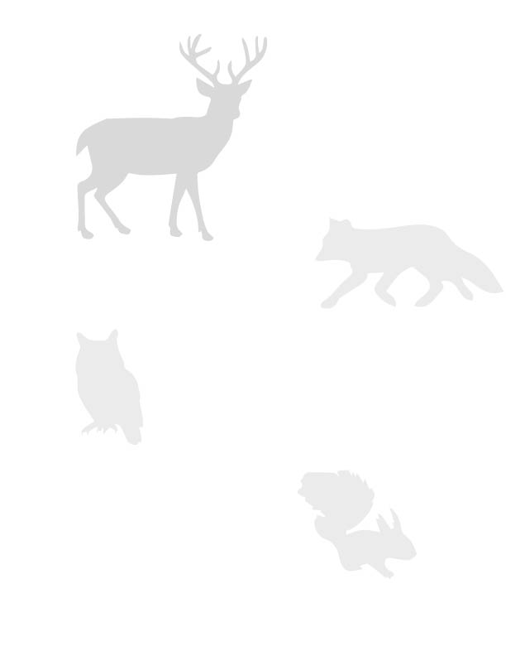
Species are going extinct for two reasons.
The first is that wildlife populations are dying off directly from human activities such as hunting, fishing and pollution. For instance, when farmers spray crops with toxic chemicals, a certain amount of plants, bugs and animals are killed. When fisherman fish, fish populations are reduced. When hunters hunt, and poachers poach, animal populations tend to decline.
The second reason, and perhaps the more important reason is that human activities impact the web of relationships within ecosystems. If we took the steering wheel out of car, it is very likely that the whole car would not function well very soon. The same is true with an ecosystem. When humans impact certain species in ecosystems, and take away animals’ homes, this impacts the whole ecosystem. For instance, big fish eat small fish, so when we fish away all the small fish, the bigger fish are left without food, and the fish that eat those fish are also left without food.
Of all human activities, those which impact forests and water have the greatest impact on biodiversity. Forests are home to 80% of land-based biodiversity. Every minute approximately 27 soccer fields of forest are lost. This adds up to 18.7 million acres per year.
When we take away trees, forests lose their capacity to recycle water, to provide habitat to many species, to keep the earth’s temperatures the same, to protect river banks, and to soak up energy from the sun. Today, 85% of all threatened and endangered species are going extinct because we are taking away homes for animals. Forest loss is the main cause of habitat loss.
Let’s talk about two types of economic activities that hurt other species the most.
1. Building cities: As we build new houses, roads, malls, buildings, and pave parking lots we are both taking away animal homes and reducing the amount of space which animals can live.
2. Growing food: Fields for growing food now cover almost half of the world’s land. Because of this many of our forests are now gone. It is possible to grow food in a way which is good for nature, but mostly, the way we grow food is bad for nature. Chemicals harm soil and hurt species that are part of the food chain. Most of our food growing is very harmful to wildlife habitat.
We have lost 3/4 of all the plant species that we eat since 1900 and now we mostly eat only three plants: rice, maize and wheat.
Conclusion:
As populations grow, we need more and more land to feed people and we also need more houses and shopping areas for these humans. However, the land used for growing food and building houses was once the home to many species. As these species lose their homes, not only do they go extinct, they also impact the whole food web in an ecosystem. This is not good for the ecosystem because all these species work together in community to provide habitat.
All of this is not good for humans or the human economy, because our economies depend on healthy functioning ecosystems. For these reasons, democracies should decide what the right amount of economic activity is, so that the economy is stable, and we conserve wildlife according to our values.
Economics and the Web of Life

1. Name your favorite species that has gone extinct and explain why this species is your favorite.

2. What are the major causes of species extinction in recent history?

3. Survival of the fittest

Survival of the fittest means that the most well adapted species survive. Are the fit species the ones which are the strongest, the fastest, and the biggest? Not necessarily! We can think of fitness, more like the way we think of the way our shoes fit, the way that keys fit into a lock, or the way that puzzle pieces fit together. Species thrive in community, with plenty of plant and animal friends. What does this mean for humans? Is more power, technology and economic growth always better?

