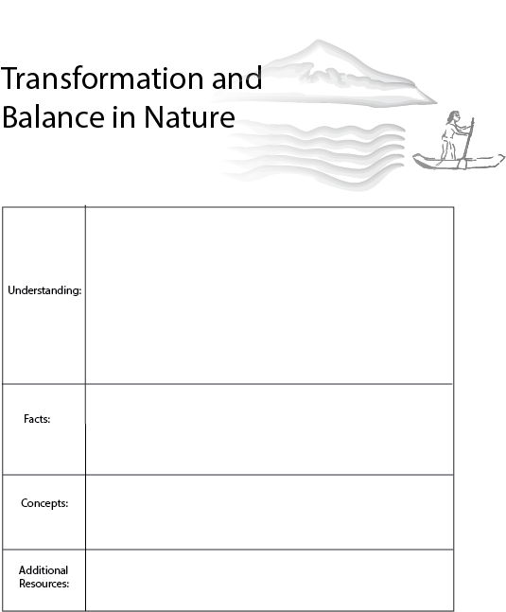

On the nature of exponential growth activity:
https://www.youtube.com/watch?v=AmFMJC45f1Q
The Anthropocene: https://www.youtube.com/watch?v=3WpaLt_Blr4&feature=youtu.be
-Balance between economy and nature
-Empty world vs. full world
-Exponential growth, positive feedback, and negative feedback
-Roughly 12,000 years ago, nature found a new balance, and the temperature became stable instead of constantly changing.
-Human population has grown exponentially.
-Resource consumption has grown exponentially.
-Species extinctions have grown exponentially.
10,000 B.C. roughly marks the beginning of human civilization. Earth’s temperatures had warmed, and the climate had stabilized. This change in climate preceded rapid growth in ecosystems, exponential growth in the human population, and exponential growth in economic activity.
Early economics was set in an “empty world” with very few humans and an abundance of ecosystems . Now, we are in a “full world” with limited resources and large populations.
In this full world, humans must operate economic systems that are in harmony with ecosystems, rather than economic systems that grow exponentially and damage or destroy ecosystems.

Lesson 1: A History of Growth
Introduction
10,000 BC roughly marks the beginning of human civilization. Economists consider this an ”empty world”, because human impact on the environment was low, and natural resources were abundant. Over time, as agriculture expanded, populations grew, social institutions developed, and our ancestors paved the way for the development of modern industrialized societies.
A Brief History
12,000 years ago, about three million humans inhabited the earth. If you lived during this period, your community would consist of about 30 people. Your house would be a small shelter built from grass, stone, and animal hide. Unfortunately, because of disease, you would have little chance of surviving beyond 40 years old.
Despite the challenges, life had its joys. During the day, life revolved primarily around sustenance. Time was spent hunting, gathering, and preparing food. At night, traditional songs, stories, and dances would connect you with knowledge of past generations.
At the time, you would have several basic technologies including the power to light a fire, spears, bow and arrows, and perhaps rope. The other good news is that the earth is emerging from a long ice age. Forests, fisheries, and ecosystems of all kind begin to overflow with life in its many forms.
Over thousands of years, agriculture develops, and village populations grow. For the first time, roughly 5,000 years ago, we see great civilizations emerge in the Middle East and Northern Africa, and thousands of years later in Asia, the Americas, and Europe. During this time social institutions such as religion created cohesion among large populations.
With an increase in trade, certain items began to take on symbolic value, like shells and ornaments. This laid the groundwork for the creation of money and economic activity as we know it today.
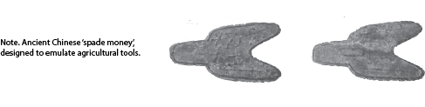

The Anthropocene
Since that period 12,000 years ago, human populations have grown 1,400 times larger. We have also seen extreme growth in technological advancement, which has enabled humans to expand their reach and manipulate the environment in new ways. Humans have had such a massive impact on earth systems that Geologists are considering renaming the current epoch the ”Anthropocene” (Geologic era of humans.)
The defining characteristic of the Anthropocene is that humans have become a dominant force in the ecosystem. This new era presents opportunities and challenges for humans and other animals that are unlike the opportunities and challenges of the past.
With modern scientific capabilities, we see that the environment has been changing faster and faster for thousands of years. Changes to our water systems, our forests, and our climate are exponential. These changes are occurring faster as our population grows, and we consume and produce more economic goods and services.
Exponential Growth
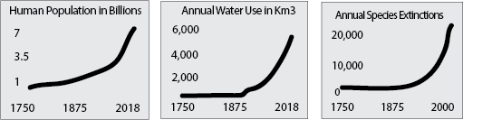
Exponential growth is a unique and powerful phenomenon that occasionally occurs in nature, for a short period. Let’s consider an example: imagine folding a piece of paper in half 25 times. How thick do you think this paper would be? It would be a quarter mile thick! Imagine you folded the paper five more times. Now the paper would be 6.67 miles thick. After 45 folds, the paper could reach to the moon. Of course in reality, it is impossible to make more than 6 folds or so.
As this paper-folding example shows, exponential patterns cause rapid change. We often see exponential growth when a component in nature becomes removed from the constraints of its typical environment. For instance, when an invasive species is introduced to a new environment, that species can grow exponentially for a short period. For example, when the climate stabilized around 10,000 BC, and humans no longer depended on hunting and gathering, there was a dramatic shift that led to exponential growth in the human population.
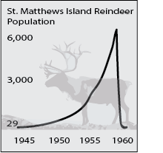
What’s the problem with exponential growth? When a new component is introduced to an environment, it takes time for the environment to adjust. Once it does, exponential growth cannot continue. Notice the population when reindeer were introduced to St. Matthews (as can be seen in the graph to the left.) Being on a new Island, food was plentiful and there were no predators. The reindeer population grew exponentially.
However, after a period of exponential growth, the environment was radically changed and there was no food left. In nature, all exponential growth eventually meets a limit.
Even our paper-folding example illustrates the natural limits on exponential growth. Folding a paper one or two times is easy. However, it is nearly impossible to fold a piece of paper more than 6 times.
Empty World vs. Full World
Similarly, in an ‘empty world’, with abundant natural resources, it is easier to imagine endless exponential economic growth. With technological advancement, human civilizations have temporarily replaced the services that nature once provided with our economic infrastructure. For instance, humans were once dependent on rain for watering crops. Over time, we have increased our capacity to extract, store, and transport water, so that we are no longer dependent on rain to water plants and can instead use irrigation systems that pump water from below. However, today, 2.7 billion people are living with water scarcity, and we continue to extract fresh water much faster than it can be regenerated. In an empty world, nature was so abundant that we could ignore environmental constraints. Today, we are in a full world; our economies must account for the inputs we receive from the environment, and the constraints which our environment imposes upon further economic activity.
Imagine a group of loggers in an empty world: With abundant forest, loggers could earn more money by hiring more labor and improving their technology. With more money from more logging, these loggers could continue to invest in labor and technology and cut down even more forest. As you can see in the logging example, exponential growth is constrained only by labor, technology, and demand (which can always increase with a growing population). In a full world, we understand that trees are limited, and we can only remove trees as fast as they can grow. Similarly, if we fish too many fish, we will run out of fish. In a full world, we see that exponential growth in population and exponential growth in resource usage—will ultimately lead to collapse or decline of planetary ecosystems.
In neoclassical economic thinking, the basic model of the economy is shown as a circular flow, as in the diagram below. When we look at the circular flow diagram, we see that money flows in a circle, from producers to consumers, again and again. This circular flow creates the conditions for positive feedback; more money for producers leads to more money for labor/consumers, which leads back to more money for producers.
Circular Flow Diagram
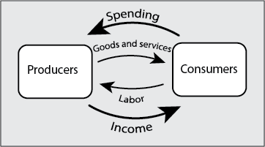
Today, economic growth is measured by an increase in Gross Domestic Product (GDP). GDP is the total value of economics goods and services consumed each year. When we look at the ”circular flow chart,” GDP is measured by the amount of spending that flows from consumers to producers in one year. The 2018 U.S. GDP was more than $18 trillion. This is roughly 18 times larger than the U.S. GDP in 1930 and double the GDP in 1998.
In this diagram, we do not see any constraint on economic growth. Considering only consumers and producers, we ignore the forests, fish, soil, solar energy, and other inputs from nature. The more consumption grows, the more production grows, and vice-versa. Exponential growth appears possible. However, today, we are in a full world, and economic activity has drastically changed our environment. We face a rate of species extinction unprecedented in 64 million years, the destabilizing of our climate, and the depletion of limited resources such as topsoil and fresh water. In this full world, we are confronted with the fact that economic activity is embedded within an ecosystem that enables and constrains economic activity.
There is an alternative to exponential economic growth. Throughout time, some economists such as Adam Smith have predicted that we would eventually transition from a growth-based economy to a steady state economy. A steady state economy is one with stable population and consumption. An economy at the ideal size—instead of endless exponential growth—is sustainable and optimizes the benefits that humans receive from nature, which are not accounted for within the economy.
An Economy Embedded within Nature
The economy transforms limited ecological resources into economic goods and services, and in the process it produces waste and changes ecosystem structures. A sustainable economy will use a stable quantity of resources and leave ecological structures intact, so that ecosystems can continue to rebuild themselves with the help of solar energy.
Economic
Activity
Conclusion
In the last 12,000 years, human population and consumption have expanded exponentially, and both continue to expand exponentially. In the last 50 years, the average American home size has tripled. Today, the average American family throws away 65 pounds of clothing per year, and the average American home contains more than 3,000 items. This is all compounded by the fact that the amount that the global population grows every couple of weeks, is more than the entire global population of 10,000 years ago.
Due to these trends, we continue to consume increasing amounts of limited resources such as water, oil, metal, timber and various chemical elements. As we cut down forests, pollute the water, air and soil, and extract resources, we impact the structure of our ecosystems and the capacity of ecosystems to regenerate. These ecosystems are a habitat for many other species and provide essential services for human civilization and human economies.
In future lesson plans, we will discuss the 21st-century transition away from exponential economic growth and toward a steady state economy, as well as the role of technology and the process of determining the right size for the economy.

Lesson One Questions: The History of Growth

1. What is a rough estimate of the human population in the year 10,000 BCE, the year 1800 and today?
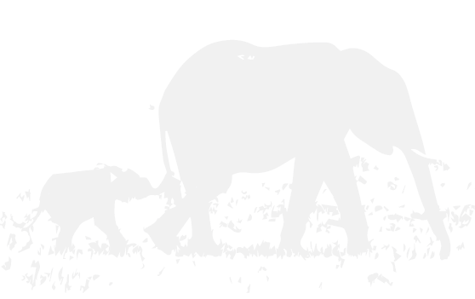

4. What is the difference between full world economics and empty world economics?

6. What is the central goal of steady state economics, discussed in this lecture?

Using the 5 E Model with this Lesson Plan

Engage:
How thick would a piece of paper be after 10, 20, 50, and 103 folds? After 103 folds it would be as thick as the known universe. Introduce the notion of exponential growth through the ‘folding paper’ activity. By googling “exponential growth, folding paper” many videos will pop up such as this:
https://www.youtube.com/watch?v=AmFMJC45f1Q
Exponential growth is a mathematical term, so let’s take a look at some mathematics.
Consider the equation: f(x)=(x+2)*2. This formula structure suggests that we continue to iterate, plugging our answer back in for x (since x is on both sides of the equation). If we start with 6, we get 16, 36, 76, 156 and after 30 iterations we have over 1 billion. It keeps growing faster and faster!
Some systems that evolve over time do not grow exponentially. Consider the equation: f(x)=f(x+2)/2 Imagine we start with x=6. F(6)=(6+2)/2=4. Because f(x) is on both sides of the equation we plug the answer (4) back in. F(4)=(4+2)/2=F(3)=(3+2)/2=F(2.5)=.... f(2)=(2+2)/2=f(2)... This is an example of negative feedback. These functions eventually find a balance at 2 so that it stays the same f(2)=(2+2)/2=(2+2)/2=2=(2+2/2)=2. Patterns such as this are sustainable, while patterns which never stabilize, are not. Perform the functions F(x)=(X+2)/2 with the number of the day you were born on.

Explore:
Task: Find examples of systems in economics and nature which have gone through periods of exponential growth, for short or long periods.
(Examples: population growth, energy use, fertilizer use, species loss, economic growth (GDP), periods of stock market growth, housing price growth, money supply.) Some more examples can be found here:
https://medium.com/future-earth-media-lab/the-anthropocene-effect-4d7ef1e2bd55
Here is a video about population growth throughout time:
https://www.youtube.com/watch?v=_HscLx0isjQ
Or go back further to understand evolution: See the “big history project”
https://school.bighistoryproject.com/bhplive

Explain:
In nature, what causes exponential growth? What constrains exponential growth?
https://www.albert.io/blog/positive-negative-feedback-loops-biology/
Why did some classical economists, such as Adam Smith, think that economies would grow toward a stationary state?
Elaborate:
Given what we have learned about exponential growth, and ecological constraints, what is missing from the ‘circular flow diagram’ of conventional economics? How would you change this model?
How should we think about the relationship between the economy and nature? How does the economy impact the ecosystem? How does the ecosystem impact the economy?
What are some limits on economic growth?
For extra credit: Understand the ‘land’ function in economics. For a long time, the fixed resource of land was considered essential economic capital. Eventually it was conveived that land was substitutable for technology and labor.
Evaluate:
Do students understand why exponential economic growth has occurred in the past?
Feedback amongst producers and consumers.
Feedback between innovation and increased resource consumption (next lesson plan.)
Can students imagine a few sub-dimensions of economic growth, which might lead to further investigation?
Increased population, increased land use, increased wealth, etc..
Do students understand that the economy is embedded within natural systems?
Do students understand the need to transition away from an economy dependent on exponential economic growth?
For teachers: Were students able to make the jump from exponential growth in math and on paper to exponential growth in nature and economies? What would better facilitate this jump?

