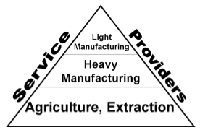
Lesson 2: The Trophic Structure
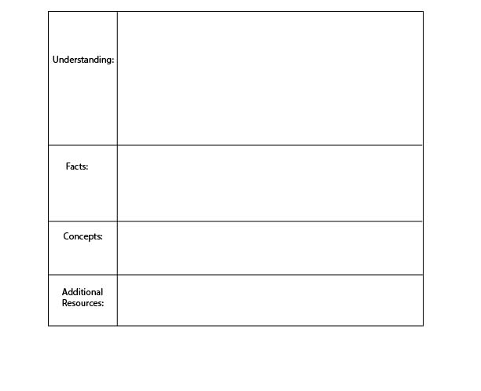
of the Economy
Food webs:
https://www.youtube.com/watch?v=Cd1M9xD482s
- Food chain/ trophic structure
-Expansion of the economic network and structure
There are three basic layers in nature’s food chain: Plants, animals that eat plants, and animals that eat animals.
There are three basic layers in the economy’s food chain: Resource extractors, heavy manufacturing, and light manufacturing.
In the economy of nature, plants are the primary producers, because they use solar energy to produce food. Some animals eat plants, and some animals eat animals that eat plants. From the sun, to plants, to animals, this flow of energy and nutrition is referred to as the trophic structure.
A similar structure exists in the economy. At the base of the economy we draw on ecological resources such as oil, timber, water, and metal. Then, there are various stages of manufacturing/ processing that add value. There is a strong relationship between what is happening at the bottom of the economy and the top of the economy.
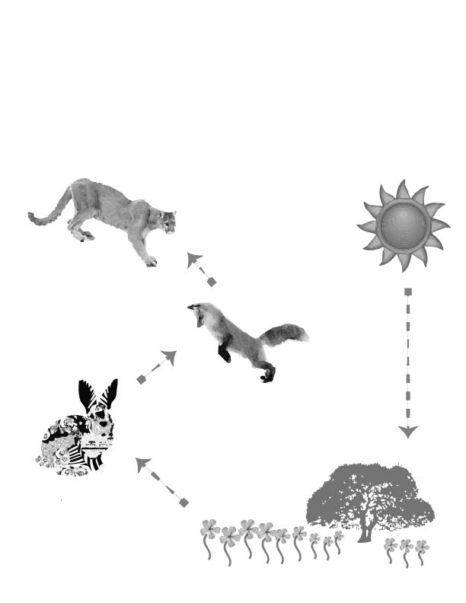
5. The top carnivores eat animals that eat animals. They’re called the higher consumers.
All of nature is linked together in what we generally refer to as the food chain and what scientists call the trophic structure. In nature, some animals eat plants, some animals eat animals that eat plants, and some animals eat animals that eat animals. All of nature starts with the energy from the sun.
In an ecosystem, the “trophic” structure refers to the flow of energy and nutrition. We can think of the trophic structure like layers in a food chain. At each level, consumers consume the level beneath them and are consumed by the level above them (unless they are at the bottom or top.)
- The sun shines down on plants providing energy.
3. Some animals only eat plants. They’re called the primary consumers.
4. Animals that eat animals that eat plants are called the secondary consumers.
- The primary producers like trees, grass and flowers get energy from the sun and with this energy they produce food for animals and insects.
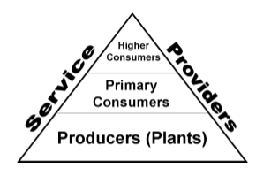
The Economic and Ecological Trophic Structures
Just as there are primary producers (plants) in nature, we also have primary producers in the economy. Primary economic producers include: farmers, miners, loggers, oil riggers, frackers, and water utilities. All of these participants are concerned with basic economic materials that can be used to create economic products. Just as plants provide basic raw materials for the economy of nature, these primary producers supply the economy with raw materials like timber, metal, oil, gas, water, and food.

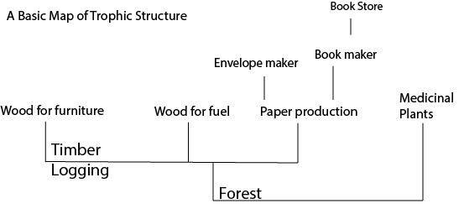
In the next stage in the economic trophic order, producers transform these raw materials into intermediary products. For instance, timber may go to a paper mill, and then to a book maker, and finally to a bookstore. The book we receive is the product of these various processes, starting with raw materials and energy. The above (simplified) representation illustrates the way raw materials are distributed through a supply chain.
Paper historians in the U.K. have estimated that there are 20,000 uses for paper. If we were to include all of these purposes for paper our graph would be extremely wide. This means there is a large diversity of products for consumers and a large number of producers competing for the same raw materials. As economies grow, these trophic structures expand in both width and height. As the graph expands in width, more types of products are created from the same fundamental natural resources.
How can a graph expand in height? Consider the many steps along a supply chain that are involved before we can walk into a book store and pick up a book, including logging, paper production, etc. Supply chains grow in height when raw materials need to be further and further refined and combined before they become a final product—the more steps involved, the taller the supply chain.
As the trophic structure expands, an economy must become more efficient, creating more “economic value” with less raw materials. Think about the value created when we combine, paper, ink, and a narrative. (We get a book!) Book stores have even combined books with cafés. Combining good and/or services, in some cases leads to greater value and in other cases leads to less value. Think about it: If the combination of pizza and pineapple were not more valuable (to some people) than the price of pizza and pineapple separately, then pizza shops would not buy pineapple, cheese, wheat, and tomatoes and sell them all together as a single product. Economies grow and expand because new combinations of materials create higher value than the materials alone.
Amazingly, many of the physical and biological principals that apply to these types of networks in the natural world also apply to economies! We can begin to relate the amount of economic activity, with the width and height of the economic network and the amount of energy and materials that an economy is using.
This also gives us an understanding for the role of technology in an economy. Some people think that technology can help us to use less resources while continuing to grow the economy, but this is because they do not understand the role of technology within the context of this economic network. Technology can either help us to expand the economy vertically, or it can help us replace an old branch of the economy. If technology helps us to increase the height or width, it increases the amount of raw materials that the economy uses, adding to the total environmental impact of the economy, and creating an even greater economic return. If technology helps us to replace an old industry, by cutting off a branch, then the environmental impact may decline, but so will total economic revenues. We will discuss this further in the next section.
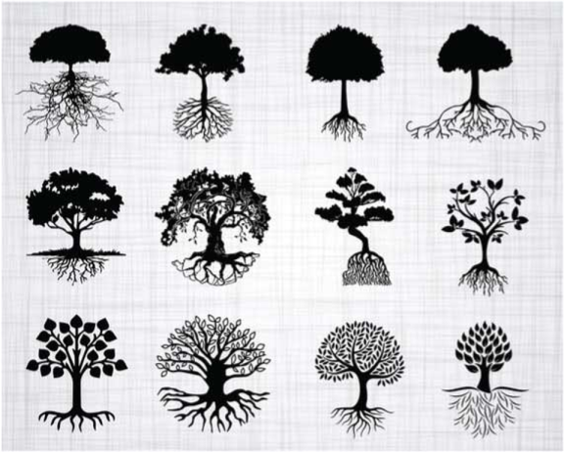
The Branches and Roots of Economic Development
When we look at a tree we see that the roots grow as the branches grow. Or, more accurately, the part of the tree that is below ground (below-ground biomass) grows in proportion to the part of the tree that is above ground (above-ground biomass). The top of the tree does not expand without the expansion of the roots. For five units of above-ground biomass growth, there is one unit of below-ground biomass growth. In other words, the roots supporting the actual tree grow in proportion to the tree.
This is also true of the economy. The more that the economy grows vertically, the more the economy must also expand at the trophic base. As the economy creates more types of products, which are worth more money, the roots of the economy—the extractive sectors—also grow proportionally.
Just as ecosystems exchange energy and nutrition, economies always exchange economic resources. As organisms grow, the networks delivering energy and nutrition expand in width and height. Just as in economies, they become more efficient as they grow and expand. For instance, humans use energy more efficiently than ants, and elephants use energy more efficiently than humans. We call this “returns to scale” because, as the scale (the size) of the organism increases, the system gets more in return per unit of energy.
This follows a strict pattern. As the weight of an organism doubles, that organism requires exactly 1.5 times the amount of energy, not 2 times! This is true for all species from mitochondria to elephants. Believe it or not, this pattern is roughly the same when we compare economic activity and energy consumption. When an economy is twice as big per capita, it consumes 1.5 as much energy. In fact, this rule holds true both between economies today and in the growth of economies through the past five decades. As the global economy has grown, it has used more and more energy in absolute terms, but less and less energy per unit of GDP. Every time the GDP has doubled, the economy has used 1.5 times as much energy.
As people innovate and develop new products within the economy, we use more and more energy and materials. As the branches of the economy grow higher, the roots of the economy grow deeper. The book store café is never disconnected from the timber used to make books and the land used to plant coffee. Progress and economic innovation always occur in this context—within a trophic structure.
Consider Google, a company that sits at the top of the economy is about 25 times as energy efficient as the US economy on average. Though google makes more money with less energy, Google makes most of its money selling advertisements for products and services that reside at lower orders of the trophic level. In 2011, Google made billions of dollars from car companies, travel companies, and other companies that lower in the trophic structure. Expansion in the service sector and the light manufacturing sector is always accompanied by expansion at the extractive base of the economy. So all levels of the trophic structure in a given case must be examined closely.

Conclusion:

Just as in nature, the economy exists within a trophic structure. At the base are the extractive sectors, which take raw materials from the earth such as timber, water, oil, and agricultural products.
The structure of the economy expands horizontally when these resources are used for a variety of different products. For instance, paper is used for thousands of different products. The structure of the economy expands vertically when these products are refined to a greater and greater degree until they are finally sold. For instance, forests can be turned into timber, which can be turned into paper, which can be turned into books, which can be combined with a café to make a book store. This vertical expansion can also be measured by the amount of money spent on processing economic products.

As the economy expands, it tends to use resources more efficiently on the path toward increasing economic revenue. A pineapple pizza is worth more than all of the ingredients sold separately. However, as the economy expands, it uses more resources in total.

Technology is a part of this economic system, which allows for greater economic returns per unit of resource, but also increases the quantity of resources in the system.

Some economists argue that economic activity is less dependent on ecological resources than it used to be. This is partially accurate. Just as an organism becomes more efficient as it grows larger, and a tree’s above-ground biomass grows faster than its roots, so too, as the economy becomes larger, the extractive sector at the base makes up a smaller and smaller proportion of GDP. The economy becomes more and more efficient per unit of resource. However, this is only possible as long as the economy is growing. And, as long as the economy is growing, total resource use continues to increase. This is a challenge because these resources are limited in nature. There is a finite amount of water, land, forest, and energy for economic production.

Intro:

The Trophic Theory of Money Game allows students to develop and maintain an ecosystem and an economy. The rules of the game are structured to incorporate trophic structures in both the ecosystem and the economy. The game operates in cycles of 1 year. Each year, students decide to either develop their economy, or to allow their forest to grow. At the end of each year, students keep account of what they possess including forest, economic development and money. At the beginning of each year, each team is rewarded with ecological growth and/or economic returns, but they must also pay what is due, in order to maintain their economy. In more advanced forms, more complex rules can apply that portray ecological dynamics and macroeconomic parameters. Some of this rule development can be taken on by students, prompted by teachers.

Teachers and students can begin by printing and cutting out the materials provided in this document. It will also be useful for students/student teams to have their own ”Economic Accounting Chart”, and ”Economic Pyramid”. (It is recommended to play in teams of 3-4 people, in order to promote discourse.)

1. Each team begins with a forest of 10 trees, 0 economic pieces, 0 dollars, and earning 0 revenue. Because there are ten trees, the forest is inhabited by rabbits. Students account for this in their EEconomic Accounting Chart”.

2. Teams decide whether to use forest in order to develop their economy or allow their forest to grow. Forest growth is determined by the “Tree Surplus Chart”, according to the size of the forest.

3. In order to develop the economy, refer to the economic pyramid chart. Each unit of economic development is bought with a mix of forest and money, has an associated maintenance cost, and yields certain returns. Students can keep track of their progress with symbolic markers such as blocks or using a pen/pencil. Economic development occurs by paying the teacher the quantity suggested and tracking economic development accordingly.

4. At the end of year within the game, students mark their progress in their “Economic Accounting Chart”.

5. At the beginning of each season, teams gain trees according to the size of their forests, gain money according to their economic development, and pay maintenance according to their economic development as defined by the chart.

6. The ending point of the game can be modified by teachers and participants. Various goals and time periods can be assigned. For instance: highest sustainable economy within 12 rounds or highest GDP within 10 rounds. Deciding which scenario wins opens the door for a broader discussion on what the goal should be, and how it could be kept track of (which is emphasized in future lesson plans.)

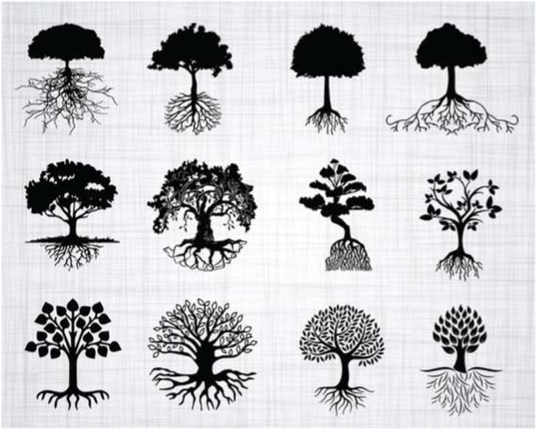
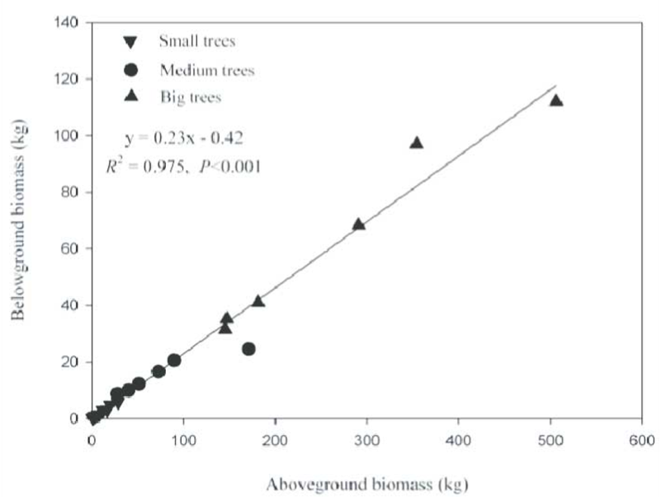
Applying 5E to the Trophic Theory of Money Game:
When trees grow, do they only grow, do they only grow up in height? When we look at a tree, we see that the roots grow as the branches grow. Or, more accurately, the part of the tree that is below ground (below ground biomass) grows in proportion to the part of the tree that is above ground (above ground biomass). The top of the tree does not expand, without the expansion of the roots.
This is also true of the economy. The more that the economy grows vertically, the more the economy must also expand at the base.
The graph to the right demonstrates this relationship with trees. For five units of above ground biomass growth, there is one unit of below ground biomass growth.
When we think about the trophic structure of the economy the same thing is true. As the economy creates more types of products, which are worth more money, the extractive sectors (the roots of the economy) also grow proportionally, albeit more slowly.

1. Engage:
Students play game.

2. Explore:
Students collectively deliberate on certain strategies within groups and occassional strategy discussion is held across groups as various rates of economic development occur.

3. Explain:
Students reflect/ discuss why some strategies were more effective than others, and reflect on unexpected consequences of various strategies.

4. Elaborate:
Students consider the extent to which this game reflects the national/ global economy. How would this game be different with abiotic resources?

5. Evaluate:
Evaluate the rules of the game/ speed of play based on the extent to which dynamics of growth, collapse, and steady states were present during play.

Also, this game can be modified to include ecological variables such as weather events, and macroeconomic variables such as the availability of money. Discuss and refine the game according to interests.

Lesson 2: The Trophic Structure of the Economy

Who are the primary producers in the human economy?

How do these primary producers depend on solar energy?

Approximately, how many more heart beats does a human have in one lifetime than a rabbit? How many heart beats does a fox have in one lifetime?

Discuss the notion of ‘returns to scale’. Using your own critical thinking skills, why don’t we have organisms that are infinitely huge? And, considering the trophic structure, what happens if the economy becomes too big?

Political question: Often times, when environmental regulations are imposed, producers which are higher in the trophic order can substitute for different inputs, and yet producers which are lower in the trophic order are directly impacted, such as coal miners. Using your imagination and some basic research, think of a plan for addressing the tension between environmental constraints and primary economic producers.

