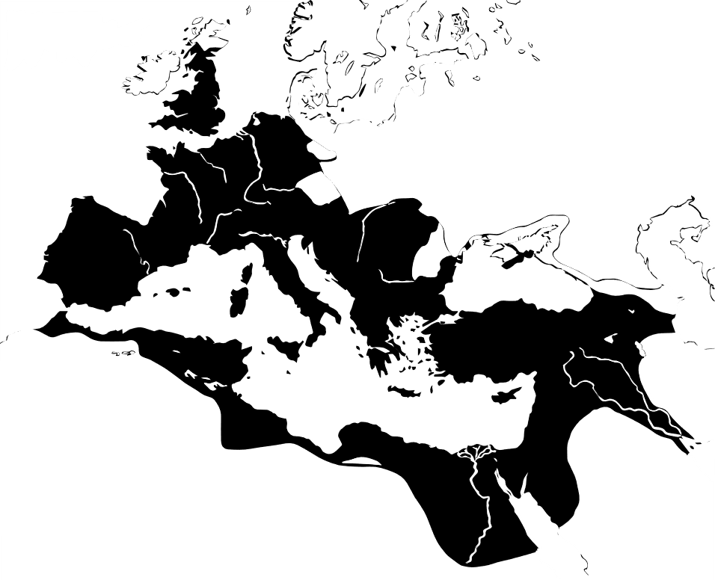

Economic Growth and
Supply Chain Expansion

Understanding: | Throughout history, economic growth has corresponded with the expansion of trade networks across larger and larger distances. This expansion created an opportunity for population size and per capita consumption to increase. It also allowed urban populations to grow and gain access to resources beyond their local regions. However, the costs of expansion eventually become high, and when expansion costs rise, resource constraints have negative impacts on economies and people. In the face of resource constraints, pressures force further urbanization, and, at the same time, pressures undermine the sustainability of urban populations.
Facts: | - The population of Rome grew steadily throughout the period of the Roman Empire.  - Resource consumption grew steadily throughout the period of the Roman Empire.  - As a result, resource stocks were steadily depleted throughout the Mediterranean.
Concepts: | - Stocks-flow  - Fund-service  - Carrying Capacity  - Bioregion vs. State  - Trade network expansion
Additional Resources: | History of the Roman Empire:  https://www.youtube.com/watch?v=GylVIyK6voU

Lesson 4.
Economic Growth and Supply Chain Expansion
Throughout history, economic systems have expanded across landscapes in order to gain access to new resources. For instance, the ancient Romans made their way across both sea and land, in ships and carriages, bringing products from one city to another. Far from home, the Romans collected food taxes and traded for economic products. They got wheat from Alexandria, olives from Thessalonica, lumber from Sirmium, Gold from Libya, and fish at many ports around the Mediterranean Sea. With this increased access to resources, the economy grew and the population of Rome grew. However, eventually resources declined and further expansion was too costly.
Trade on the Mediterranean
As Roman merchants traveled farther and farther, they not only gained access to the olives of Thessalonica, the Gold of Libya, and other coveted economic products, they also gained access to the various environmental conditions surrounding the Mediterranean; they gained access to different resources and weather patterns. Although the Mediterranean region generally featured rainy winters and dry summers, there were also many differences in environmental conditions that surrounded the Mediterranean. The trade networks of the Roman Empire reflected these changes. When there was a drought in one region, and agricultural yields were not strong, the Romans could buy food from another region. These interactions with the environment shaped the economies of Rome and the surrounding regions.
For instance, during the period of the Roman Empire, Spain enjoyed heavy rainfall, so Rome imported many agricultural products from Spain. However, the rainfall was not very consistent, so instead of importing a staple crop that Romans relied on consistently, olives and wine became major exports of Spain. Rome and Spain traded agricultural products such as olives and wine, but some scholars focus on the water that was required to produce food. They call this the virtual water trade, because the water was required to produce food. Ultimately, water was a major source of Roman economic success, and the reason for the decline of the Roman Empire.
Carrying Capacity
A population depends on a certain quantity of resources, such as forests, land, and water. A population that consumes a lot of resources per person, will obviously require more resources. If everyone wants to live luxuriously, the environment will support fewer people. The carrying capacity of a region is defined as the number of people the environment can support in that region. We can ask the following questions: What resources are available for consumption in this region? How fast do these resources regenerate? How much of each resource is consumed by each person? Is the population the right size, too big, or could it be bigger?
Throughout history, many populations have gone beyond their carrying capacity by consuming too much or by overgrowing the population. What happens when a population grows beyond its carrying capacity? Sometimes, the population collapses, and there is misery due to lack of resources. Sometimes a population learns to use resources more efficiently or begins consuming less. Other times, when economies exceed their local carrying capacity, they expand to new regions and consume the resources of neighboring regions. They may gain access to these resources through economic trade or political force. For instance, in the Roman Empire, many of the local forests were cut down, and the agricultural land was worn out. As the Empire expanded, more and more forests were cut down in neighboring regions.
Then, eventually, the carrying capacity of the entire Mediterranean was exceeded by the Roman Empire, which consumed more forests and water resources than were available.
Carrying capacity is not the maximum consumption that can take place at any given moment. It is the maximum population/consumption that can be sustainably maintained. When a population overshoots their carrying capacity, they will eventually begin to experience resource constraints. These constraints themselves can be the indirect cause of collapse as they exacerbate social, political, and economic tensions.
Carrying capacity is defined by the stocks and flows, as well as the funds and services of a given region.
A stock is an available quantity of ecological resources at a fixed point in time, such as a certain quantity of water or a stock of lumber.
A stock can be depleted and regenerated. For instance, trees can be cut down, decreasing the stock, and trees can grow, increasing the stock. Likewise, water can flow into a lake and flow out of a lake, impacting the size of the stock of water (the lake). We can use the metaphor of a bathtub as illustrated below.
Stocks and Flows – Illustrated by a Bathtub

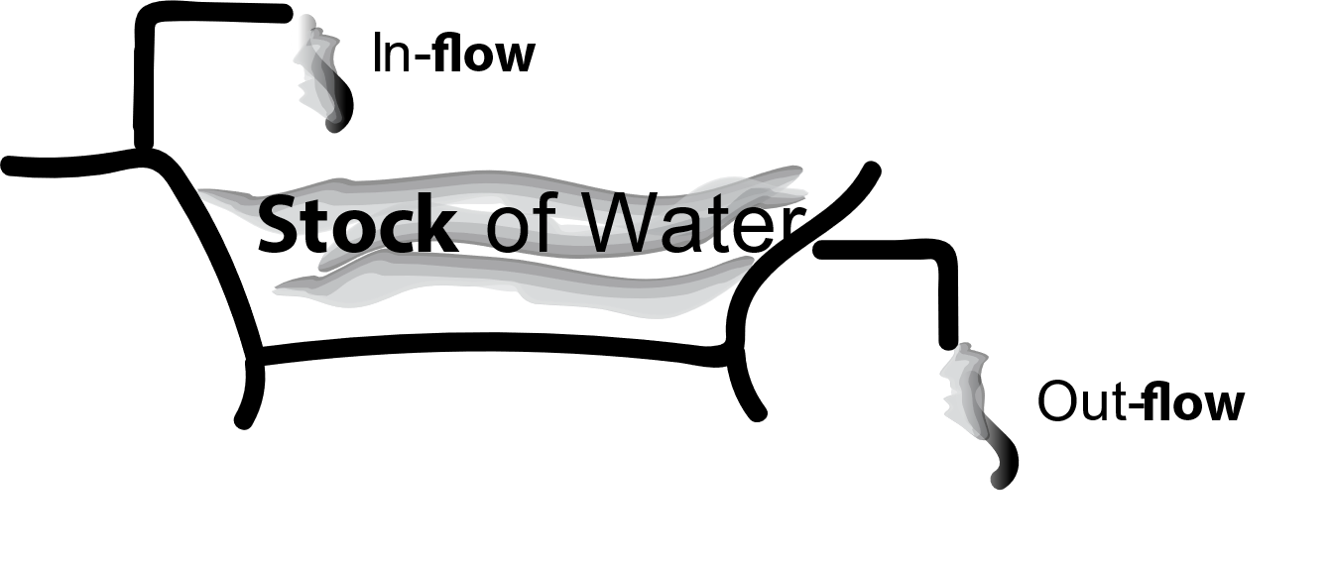

Stocks and Flows
It is essential to remember that stocks of energy and raw materials from nature serve as the basis for all economic activity.
There are many types of stocks that economies depend on: timber in a forest, freshwater in a lake, metals in a mine, as well as energy stocks such as oil and coal. In the Roman Empire, timber from forests served as fuel and as material for furniture.
If an economy is sustainable, then the economy will not deplete stocks faster than they can be regenerated. For instance, a sustainable economy will extract no more trees than can be regrown in the same time period.
Trees that are extracted and converted into economic activity are considered a flow. A flow is a quantity of resources that move through a system over a given time period.
The Roman Empire consumed a certain amount of timber each year. This is a flow of timber. Each year, an economy consumes a certain amount of energy. This energy flows through the economy throughout the year. Each year, an economy consumes a certain quantity of fresh water. This freshwater flows through the economy.
A sustainable economy, or steady state economy, is one with a sustainable flow of resources through the economy.
Stocks and flows are related aspects of an ecosystem. A stock turns into a flow. Trees that were once in the forest become a flow of lumber through the economic process. Similarly, water that was once in a lake moves through the economic process.
But there is more we need to consider in order to fully understand the carrying capacity of a region. A stock of trees provides more than timber. It also provides ecosystem services.
Funds and Services
Stocks and flows play an important part in the economic process, but there is much more to it! Stocks and flows are the substance of the economic process. When we buy a pizza, we are eating the stocks and flows of nature. We are consuming the tomatoes, and the wheat, and cheese, and the water used to make the pizza. All of these were once stocks of energy and matter in the environment, and when we consume them, they provide our own physical bodies with energy and matter. But there are other essential ingredients in the economic process that are not used up like this, that do not flow into the production process and become part of the product. For instance, though we may eat pizza, we do not consume the pizza oven. The pizza oven will still be intact after we eat the pizza. The pizza oven does not flow into the pizza. The pizza oven can also be used to make the next pizza. The pizza oven is not a stock that flows through the production process, it is a fund that provides a service.
Previously we referred to forests as a stock-flow, because forests can be seen as a quantity of resources that can be used up in the economic process. Trees exist as a stock and can flow through the economy as energy or material. However, forests can also be understood as a fund-service. Forests perform the service of cleaning our air and water, providing habitat for important species such as pollinators, and provide the service of creating stable weather patterns, with nutrient and water cycles. All these services are important for preserving nature and sustaining a population. Forests also regenerate themselves so that we have future stocks and flows.
Whenever we use a stock from the ecosystem, we also impact the structure of the ecosystem and the services that the ecosystem provides. For instance, when we cut down trees to use them for heating our homes, we also impact the ability of the forest to provide habitat and cycle water.
When we consider the stock-flows and fund-services available to a given economy, we can learn a lot about why economies expand in the way that they do. In this analysis, rather than focus on political boundaries, it is helpful to focus on bioregions.
Which question are you more likely to hear:
“What is the population of New York?”
Or,
“What is the population of the New York Watershed?”
When we talk about population, we often refer to socially-determined regions: towns, cities, states, and nations. We talk about Arlington, or New York, or Ireland. It is much less common to talk about eco-regions or bioregions. A bioregion is a region defined by characteristics of the natural environment, such as a watershed. A watershed is a bioregion defined by the way water flows over a landscape.
However, when we think about the growth and decline of economies, we often learn as much by considering bioregions (such as watersheds), as we do by focusing on political regions, e.g., New York or Ireland.
Within a given bioregion, natural systems such as water cycles and weather patterns are connected. The water, the land, the forests, and the agriculture all impact each other. For instance, if a forest is cut down, it is likely to impact rivers, as well as animal habitat, both of which will impact the region's agriculture.
Also, within a given bioregion, there will be certain stock-flows and fund-services that are unique to that bioregion. A given bioregion may be a desert, or it may have lots of forests or grasslands. The economic activity in a bioregion will be shaped by the natural constraints and available resources within that region. An economy in a desert is unlikely to have an economy based on agriculture and timber. However, it may trade with other bioregions in order to gain access to these resources.
Putting it all together: The Roman Empire Example
Now, let’s look at a map of the Roman Empire, in order to better understand the relationship between bioregions, trade, and the growth and decline of economies.
When we look at a map of the Roman Empire, we notice one feature of the ecosystem that connects the entire Empire: the Mediterranean Sea. What aspects of the Mediterranean Sea impact the economy? First, the Mediterranean Sea provided an easy way to connect many cities and ports through the trade networks of the Empire. Merchants traveled throughout the Mediterranean Sea on ships across the lines drawn on the maps in the following section. In this way, we can consider the Mediterranean Sea as a fund-service that enables transportation. It is a feature of the natural environment that provides a service, but it is not itself used up or depleted by transportation.
Another feature of the Mediterranean region is the Mediterranean climate, which is characterized by mild, rainy winters and hot, dry summers, and supports forests, woodlands, and scrub vegetation.
The Virtual Water Trade of the Ancient Roman Empire
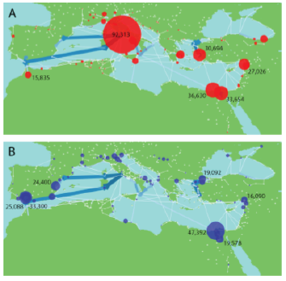
This map illustrates the Virtual Trade Network in the ancient Roman Empire. Virtual water is water that was required to produce economic products that are traded. For instance, if a farmer uses water to grow olives, and these olives are sold to consumers far away, this constitutes Virtual Water Trade. In image A red marks imports and in image B blue marks exports from each region within the Ancient Roman Empire. The thickness of the lines drawn indicate the volume of virtual water transported between nodes. As you can see, Rome was a great importer of water followed by Alexandria and Memphis in Egypt.
Figure 1 Dermody et al. (2014). “A virtual water network of the Roman world.”
On average, Rome imported 92,313 tonnes of water per year. Egypt exported the most water, and the largest consistent flows of water were between Spain and Rome. Of course, all regions with large exports of water are close to the coast or to large rivers.
When we look at the cost of water redistribution in the region, this was closely linked to climate. Researchers find that as temperatures increase cost decreases. What could explain this?
During warmer periods, agricultural yields were significantly higher. This included both rainfed and irrigated yields. This meant that there was much less demand on imports and therefore prices were lower.
At the same time an increase in urbanization leads to higher import costs because more people require imports driving prices higher. Evidence suggests that third-century crisis in the Roman Empire may resulted from a combination of fewer import options and increased costs.
Throughout time, carrying capacity has been exceeded by expansion through trade. However, eventually this expansion reaches limits. These limits can be in the form of political limits, geographical limits or economic limits. Change in an ecosystem may impact many other aspects of social and ecological systems. It is usually a combination of factors that lead to political decline.
The consideration of the natural environment—of stock-flows, fund-services, bioregions, and carrying capacities—makes broad trends predictable. These natural resources are at the foundation of the economy; during periods of natural resource constraint, social, political, and economic tensions are likely to flare up. Analogously, a human without adequate nutrition is more likely to become sick when confronted with germs.
It was during the hot, dry summers that the impact of droughts could be devastating. These droughts forced the further expansion of supply chains and caused political tension. Political tension was regular in the age of the Roman Empire. In fact 20% of Roman Emperors were assassinated. Since these assassinations are linked to periods of drought, when armies were likely to starve, researchers postulate that drought was the main cause of mutiny.
This is a reminder that changes in political and economic systems, are often connected to changes in the environment. In the case of the Roman Empire, water played a key role.
Expansion across the Mediterranean
The Roman Empire was immensely successful for several reasons, including its care for water supplies. However, its long-term trajectory was predictable. As the Roman Empire overshot resource consumption in local regions, it expanded further and further. As it expanded further, the costs of transportation and infrastructure increased, driving further liquidation of resources. The empire repeated this expansion cycle until a limit was reached. When we look at the map of the Mediterranean region, it is quite apparent at what point the costs of further expansion might be too high.
To explore the phenomenon of overshot expansion, watch the additional resources video linked on the title page, and consider the boundaries of cheap transport in the Mediterranean Sea. Expanding beyond the local region put strain on the empire by introducing increased costs for transport.
When supply chains attempt to move too far beyond regions with developed shipping routes, the limit is been reached. In some cases, these limits cause direct political and economic tensions; starving armies do not bode well for emperors or empires. In other cases, these limits cause subtle changes that strain the whole system. Increasingly, people in rural communities produced goods that had to be transported farther and farther distances, rather than producing resources for their local communities. In times of strain, people in rural communities migrated to cities. This caused some turmoil within the cities and put a higher demand on imports to the cities.
Meanwhile, the cost of transport increased, as merchants had to travel farther and farther to access new economic goods. Living conditions worsened within cities. People became sick, and the tensions between wealthy citizens and the poor increased.
Summary
Many, many factors contributed to the rise and fall of the Roman Empire, including technological change, political institutions, and cultural innovation and adaptation. In many cases, the natural environment was seemingly independent of these factors. However, on other occasions, the abundance of resources at the base of the economy played an important role in shaping the institutions that contributed to the empire’s success. But, constraints in the later stage of the empire demanded greater degrees of brute force, and naturally, the empire adopted autocratic forms of power. Modern scholars emphasize the role that water, in particular, played in periods of success and conflict. Expanding beyond the carrying capacity of its local and broader environment ultimately led to the collapse of the empire. We can consider this carrying capacity by examining the stock-flows and fund-services within bioregions and ecosystems. At times, changes in the environment meant the Roman Empire could not support communities, armies, agriculture, or trade and the empire ultimately collapsed.

References:
Dermody, Brian & van Beek, R.P.H. & Meeks, E & Klein Goldewijk, Kees & Scheide, W & Van der Velde, Ype & Bierkens, M.F.P. & Wassen, Martin & Dekker, Stefan. (2014). A virtual water network of the Roman world. Hydrology and Earth System Sciences. 11. 6561-6597. 10.5194/hessd-11-6561-2014.

5E learning model:
Engage:
This lesson focuses on the History of the Roman Empire. There are some particularly interesting stories related to the Roman Empire. For instance, the prevalence of mutiny in the Roman Empire was correlated with drought events.
Explore:
Through various online tools, we can explore the expansion of the economy of the Roman Empire. This is one resource that has developed a map of all the road networks within the Roman Empire.
http://pelagios.org/maps/greco-roman/
Explain:
Which dynamics contributed to growth and collapse in the Roman Empire? How were the resources at the base of the economy a driver of political and economic strain, or a possibility for growth?
Elaborate:
How does this notion apply to other empires which are growing and collapsing, and to our present context of exponential growth, economic expansion and global environmental challenges such as climate change?
Evaluate:
First level: understanding of carrying capacity and expansion.
Second level: understanding of the various effect of resource constraint.
Third level: able to relate this with the trophic theory and patterns of exponential growth.

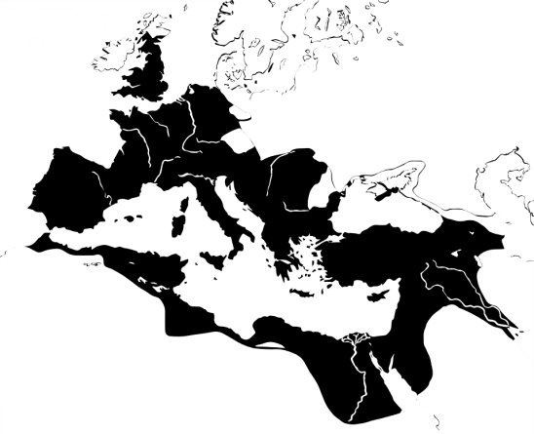
Lesson 3 Questions: Expansion of Supply Chains
Conduct online research/ investigation to support your answers.

1. What are some examples of stocks and flows that were important in the economy of the Roman Empire?

2. What are some examples of fund-services that were important in the economy of the Roman Empire?

3. What factors would be important to consider the carrying capacity of the Roman Empire?

4. What are some sources of evidence for changes in the population of Rome during the period of the Roman Empire and, the consumption of natural resources?

5. How does an analysis of the bioregion of the Mediterranean give insight into the growth and decline of the economy of the Roman Empire?

6. What environmental factors contributed to the success of the Roman Empire?

7. What technologies allowed for supply chain expansion within the Roman Empire?

