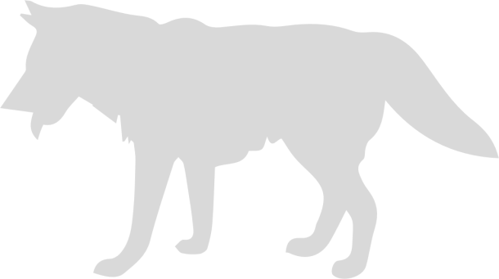
Biodiversity and
Economic Growth

Understanding: | In a short time period, we have seen a very large number of species go extinct, never to return. This is not good because ecosystems depend on biodiversity, and our economy depends on our ecosystem.  The main causes of biodiversity loss are urbanization and agriculture.
Facts: | - The current rate of biodiversity extinction is unprecedented since the time of the dinosaurs.  - Forests are very valuable for biodiversity.  - Building cities and growing food are the main drivers of biodiversity loss.
Concepts: | - Species extinction  - Habitat  - Economic causes of biodiversity loss  - Value of biodiversity
Additional Resources: | Food growing:  https://www.youtube.com/watch?v=bLqYE-m2nE4

Lesson 5. Biodiversity and Economic Growth
Our ecosystem is like a gigantic puzzle of pieces that all fit together. Each plant and animal depends on other plants and animals in its environment for food, shelter, and more. This interdependence among species is why biodiversity is so important. For instance, humans breath in oxygen and out carbon, while trees breath in carbon and out oxygen. Because of species’ diverse inputs and outputs, they can co-habitate. Scientists currently estimate that a lack of biodiversity is the number one threat to civilization and global ecosystems. More threatening than climate change, pollution, or declining freshwater reserves, is the risk of losing so many pieces of earth’s puzzle that it no longer fits together in a way that supports humanity.
Today, we see species go extinct faster than has happened for 66 million years. In raw population numbers, scientists estimate that since 1970, less than half (42%) of the wildlife population remains.
Species are going extinct for two reasons.
The first is that wildlife populations are dying directly from human activities such as hunting, fishing, and pollution. For instance, when farmers spray crops with toxic chemicals, a certain amount of plants, bugs, and animals are killed. When fisherman fish, the fish populations are reduced. When hunters hunt and poachers poach, animal populations decline.
The second reason, and perhaps the more important reason, is that human activities impact the web of relationships within ecosystems. If we took the steering wheel out of a car, the car is likely to crash and this would impact many other parts of the car. The same is true with an ecosystem. When humans impact certain species in ecosystems and take away certain animals’ homes, this impacts the whole ecosystem. For instance, many birds eat bugs. When farmers kill bugs, then birds become hungry. Big fish eat small fish, so when we fish away all the small fish, the bigger fish are left without food, and then the much bigger fish are left without food. When there is a negative change within the ecosystem, this change has a ripple effect impacting other parts of the ecosystem. This can lead to species extinction.
Of all human activities, those that impact forests and water have the greatest impact on biodiversity. Forests are home to 80% of land-based biodiversity. Every minute, approximately 27 soccer fields of forest are lost. This adds up to 18.7 million acres per year. As those acres of forest disappear, so do animals’ homes.
When we take away trees, forests lose their capacity to recycle water, provide habitat to many species, maintain the earth’s temperatures, protect river banks, and soak up energy from the sun. Today, 85% of all threatened and endangered species are going extinct because we are taking away habitat. Loss of forests is the main cause of habitat loss.
There are many economic activities that are responsible for loss of biodiversity and animal death. These include pollution, water diversion, tourism, and oil extraction. Let’s focus on the top two.
1. Building cities
As we build new houses,roads, malls, buildings, and pave parking lots, we are both replacing habitat and fragmenting habitat.
2. Growing food.
Fields for growing food now cover almost half of the earth’s land. Due to this, we have lost a lot of old forests. Some food growing can lead to healthy ecosystems, but most of our food is grown in ways that are very harmful to other species. Chemicals such as fertilizers and pesticides can harm soil and hurt species that are part of the food chain. Most of our food growing is very harmful to wildlife habitat.
We have lost 3/4 of all the plant species that we eat since 1900, and now we mostly eat only three plants: rice, maize, and wheat. Humans and human livestock now make up 96% of the biomass of organisms that are large enough to be seen with the human eye.
Some argue that it is nearly impossible to put an economic value on any given species because the ecosystem functions as an integrated whole. For instance, what is the value of mosquitoes, knowing that life on earth would collapse without them? Others work to develop economic values for biodiversity, such as the value of pollination, carbon sequestration, water filtration, and protection from storms. Applying some degree of valuation would lead to more efficient economic activity. The Economics of Ecosystems and Biodiversity initiative (TEEB) estimated that biodiversity is worth roughly half of global GDP.
To estimate the value of biodiversity, economists consider many services that biodiversity provides for economic activity. This includes everything from pollination to the harvest of wild crops such as nuts, wild blueberries, and maple syrup. In addition, various species help humans to filter and clean our ecosystems in what is called bioremediation and biotreatment. Of course, biodiversity is also essential for the functioning of forests and other ecosystems that provide raw materials as well as other benefits to humans. In addition, today, more than 50% of our medicines come from wild plants or are modeled after natural systems.
However, there are also many benefits that are hard to label with a dollar quantity. Biodiversity not only holds the global ecosystem together, but it also provides the means by which we adapt to changing ecosystems. When weather patterns change and ecosystems transform, it is biodiversity that allows ecosystems to find new arrangements, new communities, and new ways of rebuilding themselves. For instance, wild plants are constantly adapting to their environment. They are responding to pests and communicating with organisms in the soil. They use bacteria to help protect themselves and break down nutrients that they can consume. When environmental conditions change, so do the bacteria, pests, and available nutrients. Biodiversity allows plants to adapt to these changes.
The relationship between economic activity and biodiversity is one of the greatest challenges that humankind faces. Biodiversity is the background of all ecological activity. It is the fabric that goes unnoticed.

Survival of the Fittest
Survival of the Fittest
When we think about evolution, we think about survival of the fittest. But what does “fitness” really mean? Does fitness mean the strongest, the fastest, or the biggest? Usually, it does not. We can think of fitness the way we think about the way our shoes fit, the way that keys fit into a lock, or the way that puzzle pieces fit together. In ecosystems, fitness is facilitated by biodiversity and the web of relationships that allow species to survive and adapt in their environment. We tend to focus on the key, but not the lock; we focus on the foot, but not the shoe. However, if an organism erodes the environment with which they ‘fit’, they will no longer be fit.
What do this say about the story of humanity? Are we the most “fit” species? How can we improve our fitness?

Working with 5e Model:
Explain:
Which dynamics contributed to growth and collapse in the Roman Empire? How were the resources at the base of the economy a driver of political and economic strain, or a possibility for growth?
Elaborate:
How does this notion apply to other empires which are growing and collapsing, and to our present context of exponential growth, economic expansion, and global environmental challenges such as climate change?
Evaluate:
First level: understanding of carrying capacity and expansion.
Second level: understanding of the various effect of resource constraint.
Third level: able to relate this with the trophic theory and patterns of exponential growth

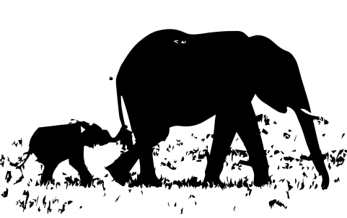
Lesson 5 Questions:
Biodiversity and Economic Growth

1. What are two major causes of species extinction in recent history?

2. Describe the difference between direct and indirect impact on wildlife that results from economic activity.

3. What is biodiversity and why is it important for ecosystem health?

4. a. Describe two approaches to protecting wildlife populations.

4. b. What are some costs and benefits of these two approaches?

